**HCMUS - VNUHCM / FIT /**

**Computer Vision & Cognitive Cybernetics Department**

**Digital Image and Video Processing Application**

**Student ID:** 21127690

**Student name:** Ngo Nguyen Thanh Thanh

**Report: Morphological Operations** (operators after week of 14 Feb 2025, binary and grayscale image)

**I. Evaluation summary:**

|  |  |  |  |  |  |
| --- | --- | --- | --- | --- | --- |
| **No** | **Types** | **Task** | **Implemetation (Without OpenCV)** | **Implementation (With OpenCV)** | **Completion (%)** |
| **1** | **Binary image** | **Binary Dilation** | Implemented using manual convolution and max filter. | Uses cv2.dilate() with a structuring element. | 100% |
| **2** | **Binary Erosion** | Implemented using manual convolution and min filter. | Uses cv2.morphologyEx(..., cv2.MORPH_OPEN). | 100% |
| **3** | **Binary Opening** | Combines manual erosion and dilation sequentially | Uses cv2.morphologyEx(..., cv2.MORPH_OPEN). | 100% |
| **4** | **Binary Closing** | Combines manual dilation and erosion sequentially. | Uses cv2.morphologyEx(..., cv2.MORPH_CLOSE). | 100% |
| **5** | **Hit-or-Miss** | Implemented using two structuring elements and logical operations. | Uses cv2.morphologyEx(..., cv2.MORPH_HITMISS). | 100% |
| **6** | **Boundary Extraction** | Subtracts eroded image from the original manually. | Uses cv2.subtract(image, cv2.erode(image, kernel)). | 100% |
| **7** | **Region Filling** | Uses iterative processing with a seed-based algorithm. | Uses OpenCV flood-fill (cv2.floodFill()). | 100% |
| **8** | **Extraction of Connected Components** | Implemented using labeling algorithms (BFS) | |  | | --- | |  |   Uses cv2.connectedComponents() | 100% |
| **9** | **Convex Hull** | Implemented using Jarvis’s March algorithm | Uses cv2.convexHull() | 100% |
| **10** | **Thinning** | Implemented using iterative Zhang-Suen thinning algorithm | Uses cv2.ximgproc.thinning() | 100% |
| **11** | **Thickening** | Implemented using dilation followed by intersection with original image |  | 100% |
| **12** | **Skeleton** | Implemented using iterative morphological thinning until convergence |  | 100% |
| **13** | **Reconstruction** | Implemented using marker-based morphological dilation |  | 100% |
| **14** | **Pruning** | Implemented using skeletonization and branch-point removal |  | 100% |
| **1** | **Gray scale** | **Grayscale Dilation** | Implemented using max filter over neighborhood | Uses cv2.dilate() | 100% |
| **2** | **Grayscale Erosion** | Implemented using min filter over neighborhood | Uses cv2.erode() | 100% |
| **3** | **Grayscale Opening** | Implemented using grayscale erosion followed by dilation | Uses cv2.morphologyEx(…, cv2.MORPH_OPEN) | 100% |
| **4** | **Grayscale Closing** | Implemented using grayscale dilation followed by erosion | Uses cv2.morphologyEx(…, cv2.MORPH_CLOSE) | 100% |
| **5** | **Grayscale smoothing** | Implemented using Gaussian or median filtering |  | 100% |
| **6** | **Grayscale Morphology Gradient** | Implemented using difference between dilation and erosion | Uses cv2.morphologyEx(…, cv2.MORPH_GRADIENT) | 100% |
| **7** | **Top-hat transformation** | Implemented using difference between original image and opened image | Uses cv2.morphologyEx(…, cv2.MORPH_TOPHAT) | 100% |
| **8** | **Textural segmentation** | Implemented using morphological filtering and thresholding |  | 100% |
| **9** | **Granulometry** | Implemented using morphological opening with increasing kernel sizes |  | 100% |
| **10** | **Reconstruction** | Implemented using marker-controlled dilation until convergence |  | 100% |

1. **List of features and file structure:**

**File structure:**

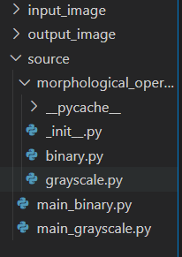

**input_image/** – Stores input images.

**output_image/** – Contains processed output images.

**source/ – Main source code directory.**

* **morphological_operations/** – Contains morphological processing modules.
  + **binary.py** – Handles binary image operations.
  + **grayscale.py** – Handles grayscale image operations.
* **main_binary.py –** Executes binary image processing.
* **main_grayscale.py** – Executes grayscale image processing.

**Functions and methods used:**

**1. binary.py (Custom Binary Image Processing Library)**

Main functions:

* **pad_image()**: Adds padding to the image to avoid errors during processing.
* **erode()**: Performs the erosion operation to shrink the bright areas.
* **dilate()**: Performs the dilation operation to expand the bright areas.
* **opening()**: Performs the opening operation (Erosion → Dilation) to remove small noise.
* **closing()**: Performs the closing operation (Dilation → Erosion) to fill small gaps.
* **hit_or_miss()**: Applies the Hit-or-Miss operation to detect specific shapes or patterns.
* **boundary_extraction()**: Extracts the boundary of the bright regions.
* **region_filling()**: Fills the bright regions based on dilation.
* **connected_components(img)** – Identifies and labels connected components in a binary image.
* **convex_hull(img)** – Computes the convex hull of bright regions using the Jarvis March algorithm.
* **thinning(img)** – Thins objects in the image using the Zhang-Suen thinning algorithm.
* **thickening(img, kernel)** – Thickens objects by applying conditional dilation.
* **skeletonization(img)** – Extracts the skeleton of objects via iterative erosion.
* **reconstruction(marker, mask, kernel)** – Reconstructs an image using dilation with constraints.
* **pruning(skeleton, iterations)** – Refines a skeleton by removing endpoints iteratively.

**2**. **grayscale.py**

Main functions:  
• **pad_image()** – Adds padding to avoid processing errors.  
• **erode()** – Applies grayscale erosion to darken bright regions.  
• **dilate()** – Applies grayscale dilation to brighten dark regions.  
• **opening()** – Performs grayscale opening (Erosion → Dilation) to remove small bright noise.  
• **closing()** – Performs grayscale closing (Dilation → Erosion) to fill small dark gaps.  
• **gradient()** – Computes the morphological gradient (Dilation - Erosion) to highlight edges.  
• **top_hat()** – Extracts small bright details using the Top-Hat transformation (Original - Opening).  
• **black_hat()** – Extracts small dark details using the Black-Hat transformation (Closing - Original).  
• **reconstruction(marker, mask, kernel)** – Restores an image using morphological reconstruction, applying both dilation (for bright regions) and erosion (for dark regions).  
• **watershed_segmentation(img, markers)** – Segments an image using the watershed algorithm.

**3. main_binary.py (Main Program)**

**Main functions:**

* Read the input image and convert it to a binary image.
* Provide two processing modes:
  + **Manual**: Use custom algorithms from **binary.py**.
  + **OpenCV**: Use the OpenCV library for processing.
* Support operations: Dilate, Erode, Open, Close, Hit-or-Miss, Boundary Extraction, Region Filling, Connected Components, Convex Hull, Thinning, Thickening, Skeletonization, Reconstruction, Pruning.
* Display and save the processed image.
* Measure and display the execution time of each method.

**Details:**

* **apply_manual(img, kernel):** Applies custom morphological operations.
* **apply_opencv(img, kernel):** Applies morphological operations using OpenCV.
* **operator(in_file, out_file, mor_op, mode, wait_key_time=0):** Processes image with specified operation and mode, displays and saves results, measures execution time.
* **main(argv):** Parses command-line arguments and calls operator() to process the image.

**4. main_grayscale.py**

**Main functions:**

* Read the input image and process it as a grayscale image.
* Provide two processing modes:
  + **Manual:** Use custom algorithms from **grayscale.py.**
  + **OpenCV:** Use the OpenCV library for processing.
* Support operations: Dilate, Erode, Open, Close, Gradient, TopHat, BlackHat, Reconstruction, Thinning, Thickening
* Display and save the processed image.
* Measure and display the execution time of each method.

**Details:**

* **apply_manual(img, kernel)** – Applies custom morphological operations for grayscale images.
* **apply_opencv(img, kernel)** – Applies grayscale morphological operations using OpenCV.
* **operator(in_file, out_file, mor_op, mode, wait_key_time=0)** – Processes the image with the specified operation and mode, displays and saves results, and measures execution time.
* **main(argv)** – Parses command-line arguments and calls operator() to process the image

**How to run code:**

**1. Install Required Libraries**

First, make sure you have the necessary libraries installed, such as opencv, numpy, and morphological_operator. You can install them using pip:

**pip install opencv-python numpy**

**Note**: The morphological_operator library appears to be a custom-written library, so make sure it exists in the same directory or has been correctly installed.

**2. Command Line Structure**

Here’s the command to run the program from the command line:

**python main.py -i <input_file> -o <output_file> [-p <morph_operator>] -m <mode> -t <wait_key_time>**

**3. Explanation of Parameters:**

* -i <input_file>: Path to the input image file.
* -o <output_file>: Path to save the result.
* -p <morph_operator> (Optional): The specific morphological operation you want to apply (e.g., "Dilate", "Erode", etc.).
* -m <mode>: The execution mode ("manual" for custom-written algorithms or "opencv" for OpenCV).
* -t <wait_key_time> (Optional): Time to wait (in milliseconds) before closing the window displaying the image.

**4. Example:**

Suppose you have an image file input.jpg and you want to apply the "Dilate" operation using the custom algorithm (manual mode) and save the result to output.jpg. You would run:

**python main.py -i input.jpg -o output.jpg -p Dilate -m manual**

**5. Options:**

* If you don't specify a morphological operation, the program will apply all available operations.
* If you don't specify a wait time, the program will not wait and will automatically close the window displaying the image.

**6. Error Information:**

If there's an error, such as a missing image file or incorrect parameter, the program will show an appropriate error message.

**Image proof**:

**Binary.py**

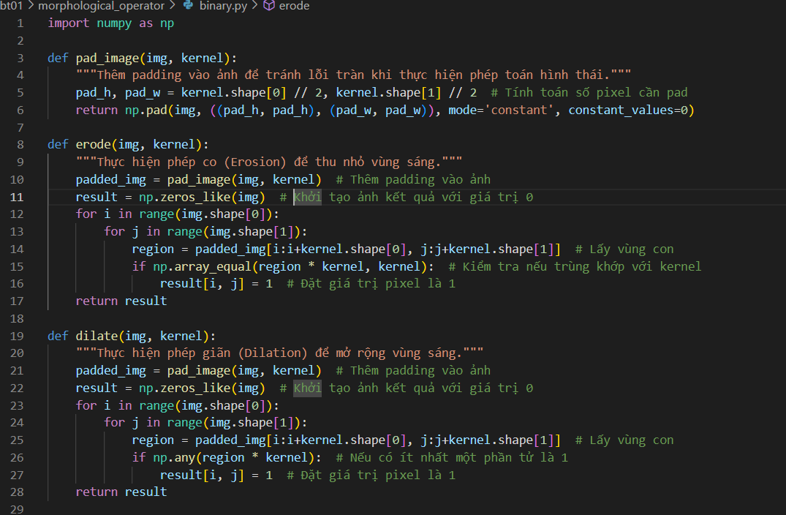

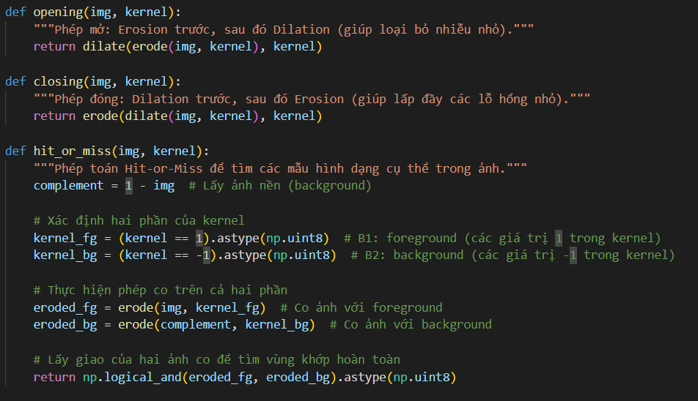

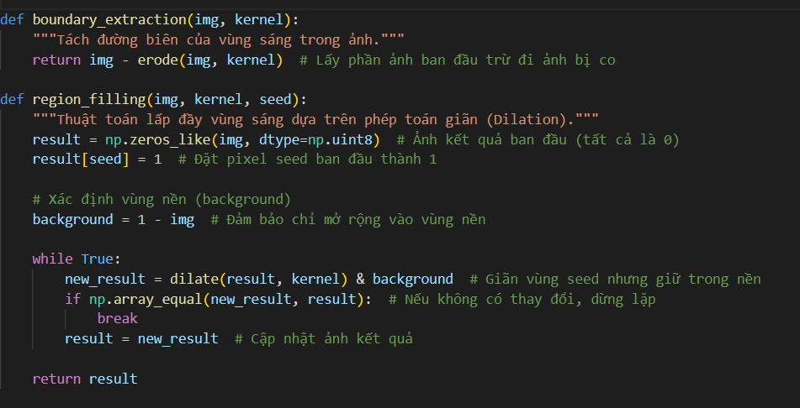

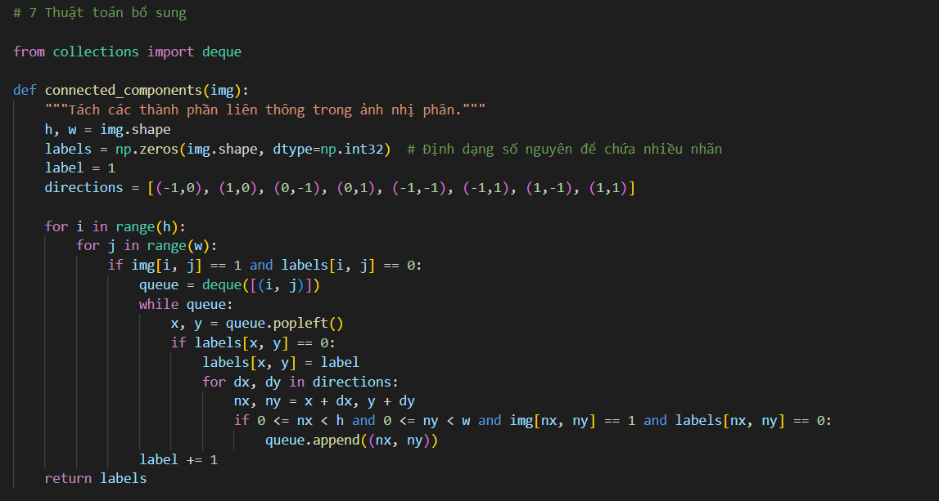

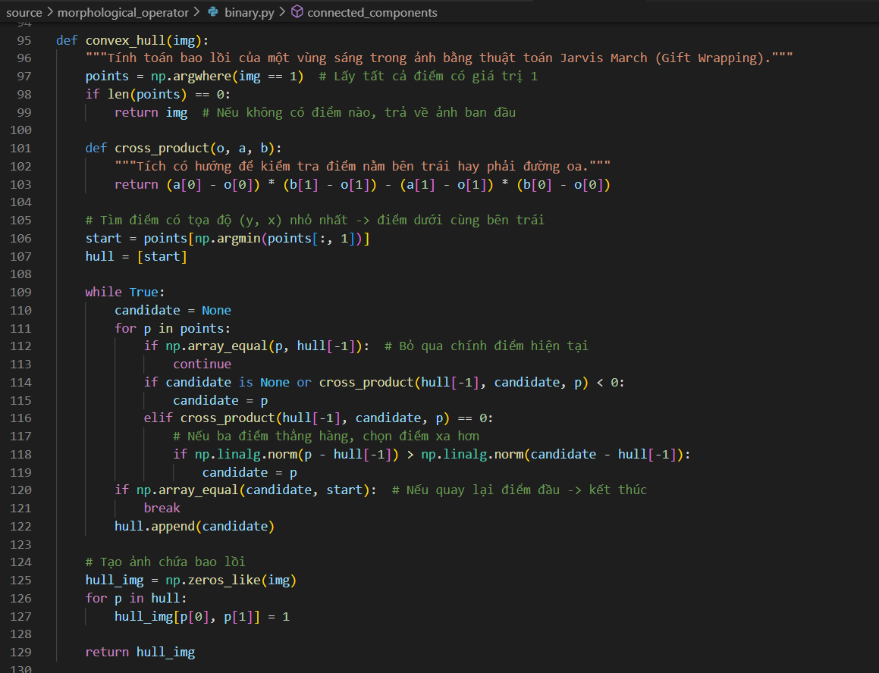

**Grayscale.py**

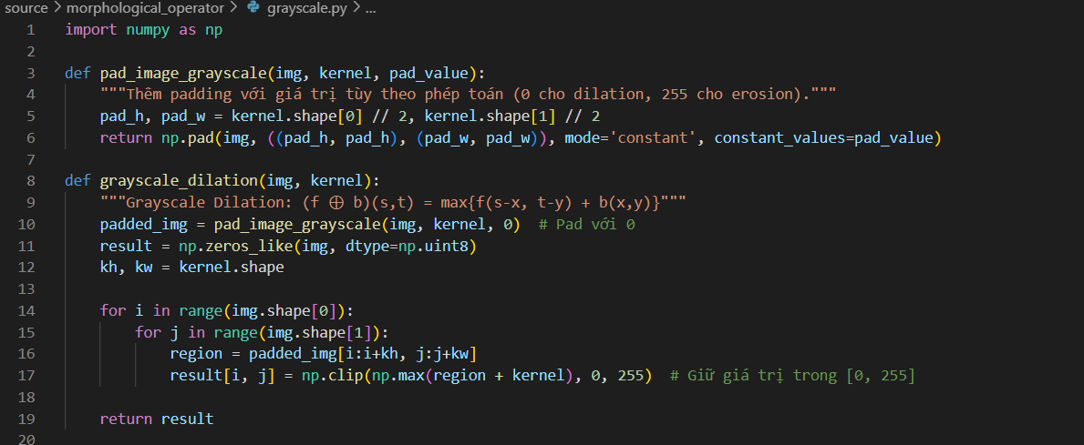

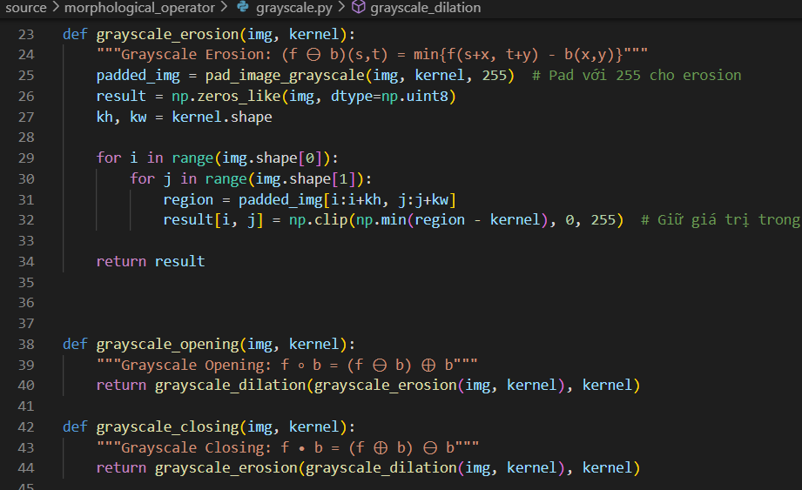

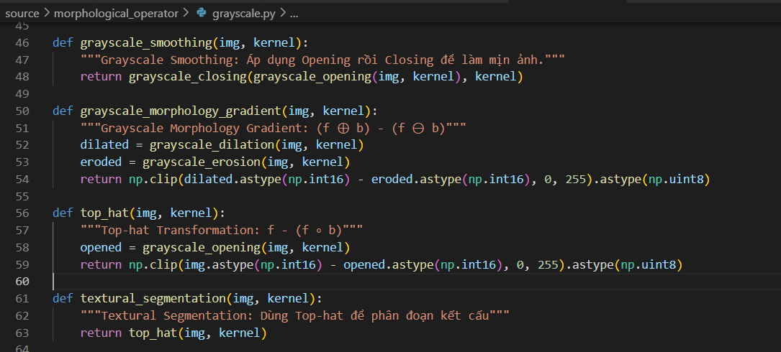

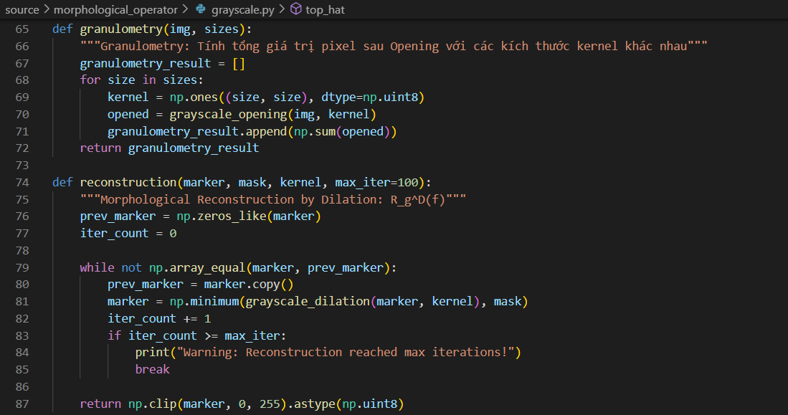

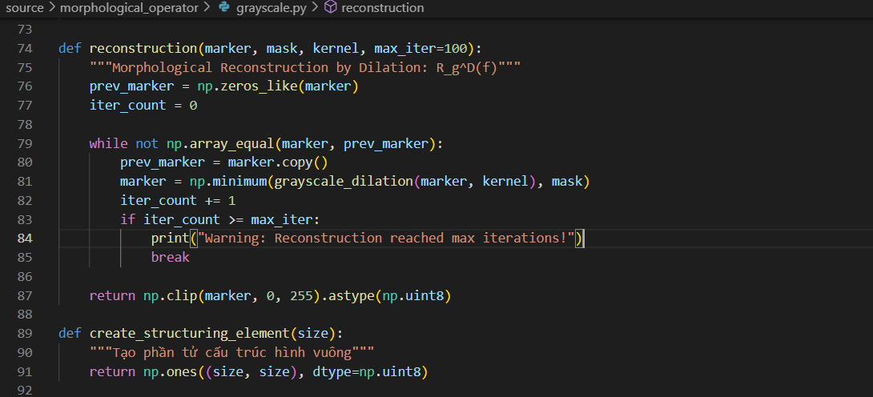

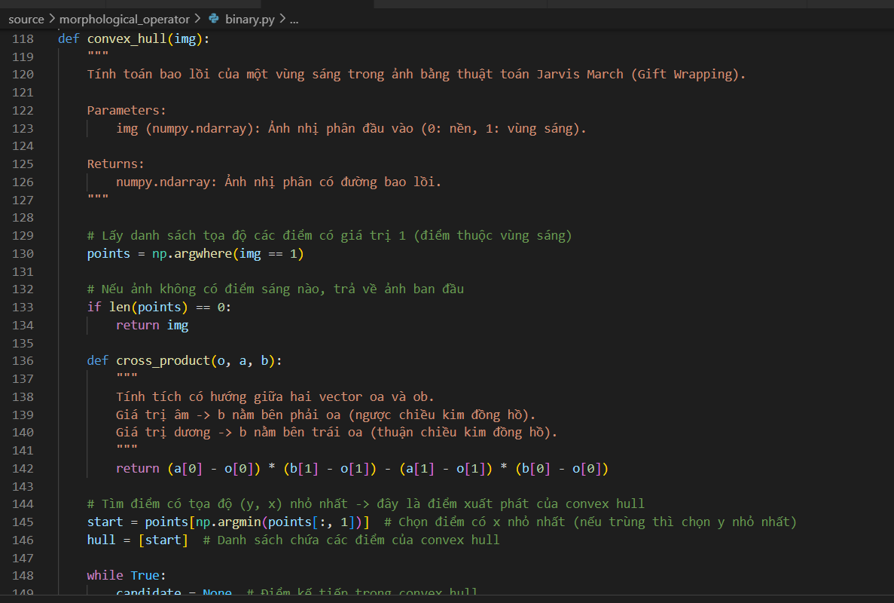

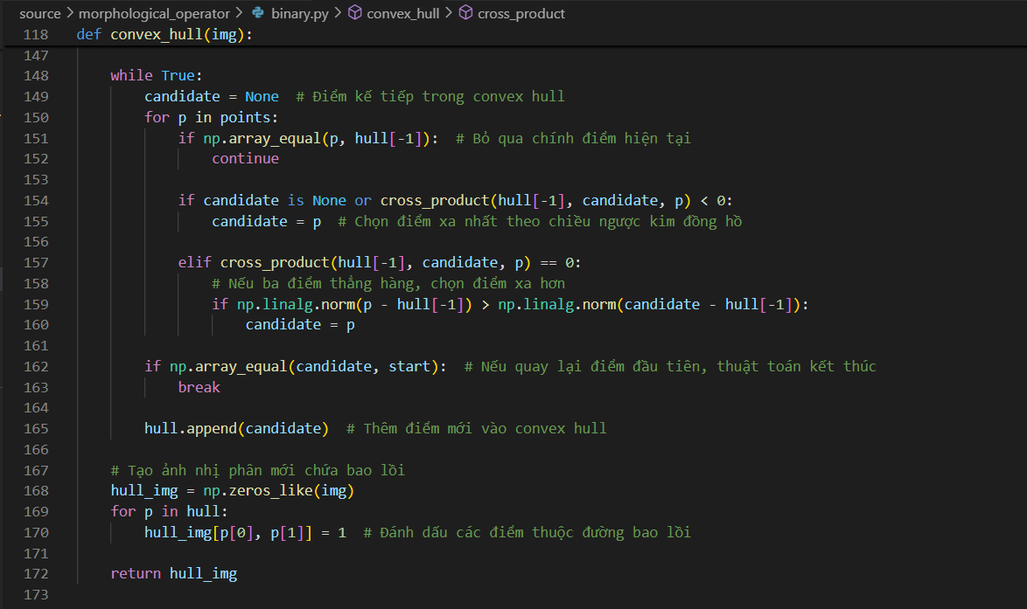

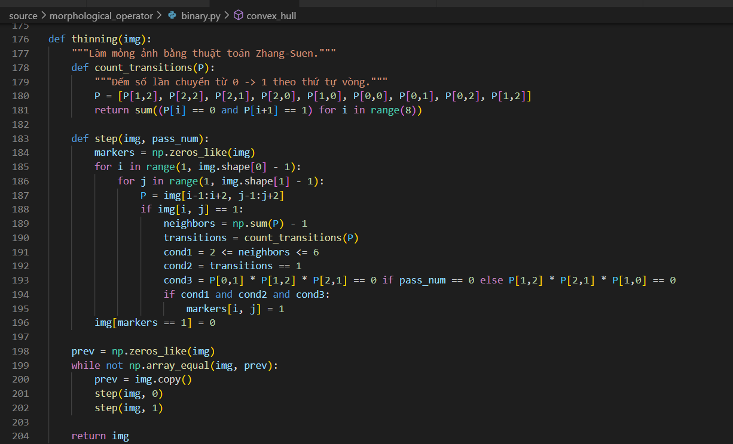

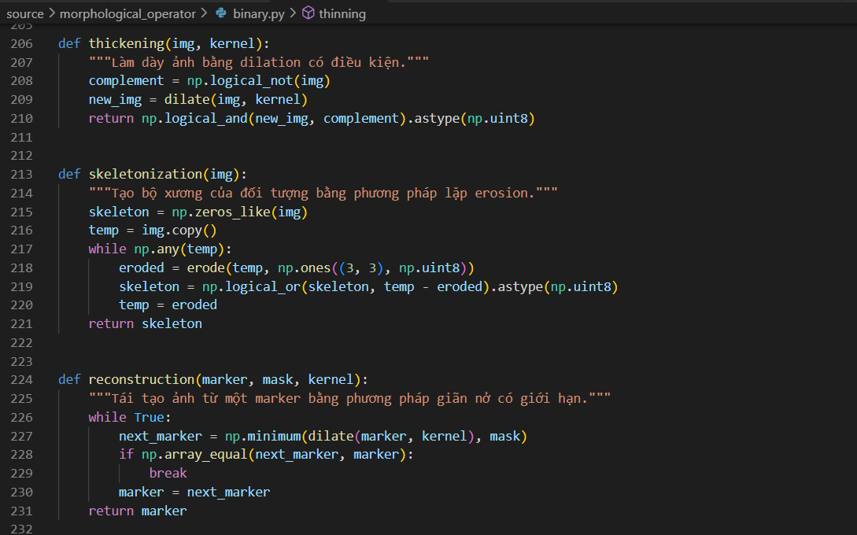

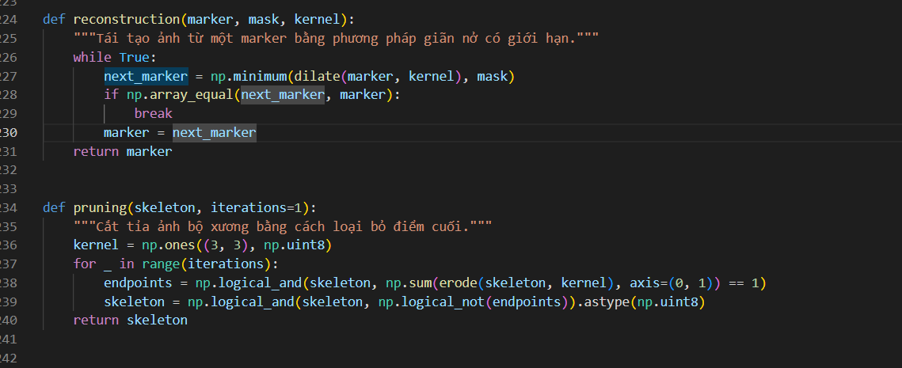

**Main_binary.py**

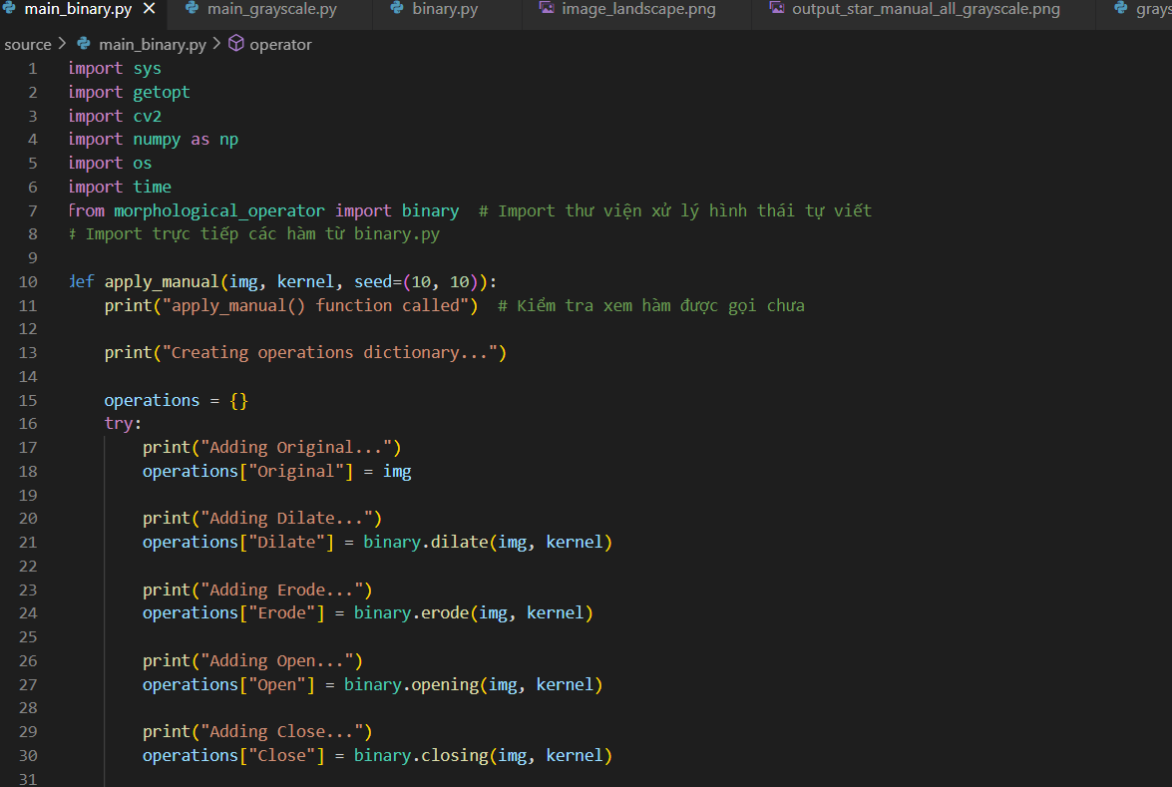

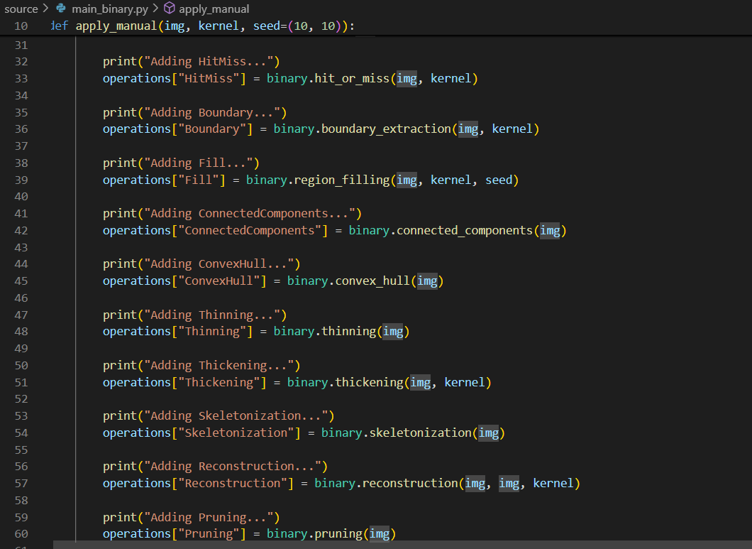

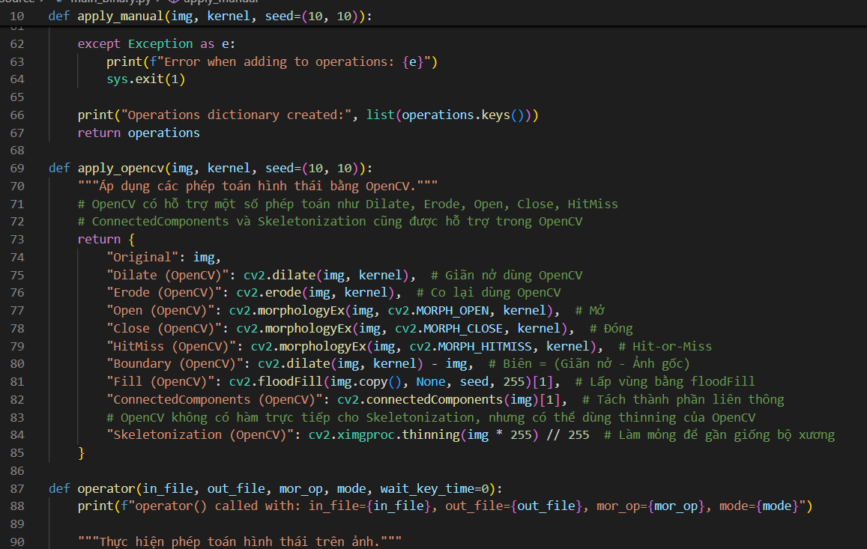

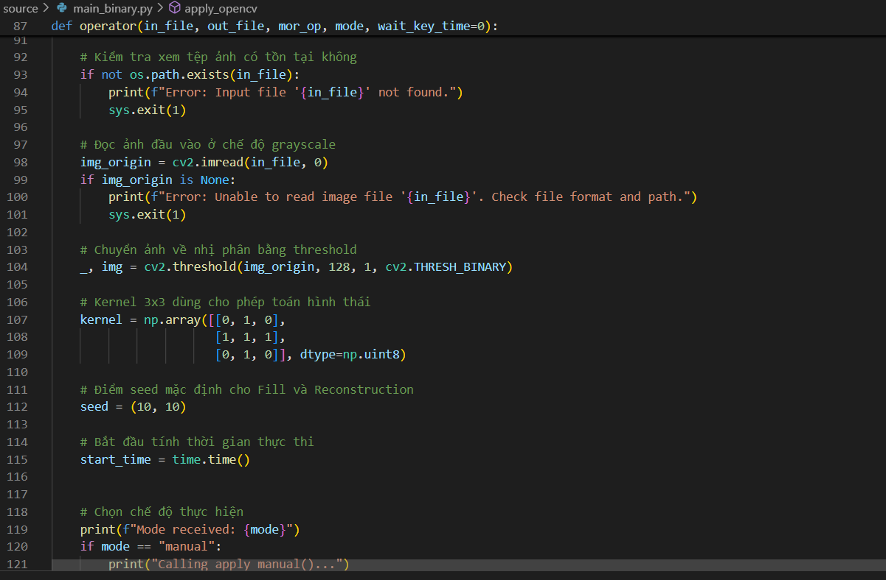

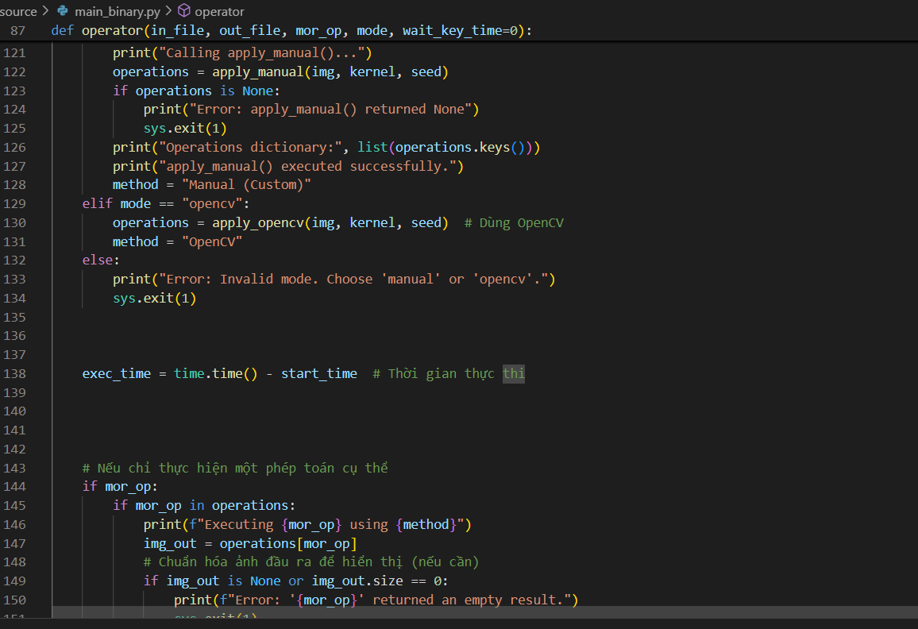

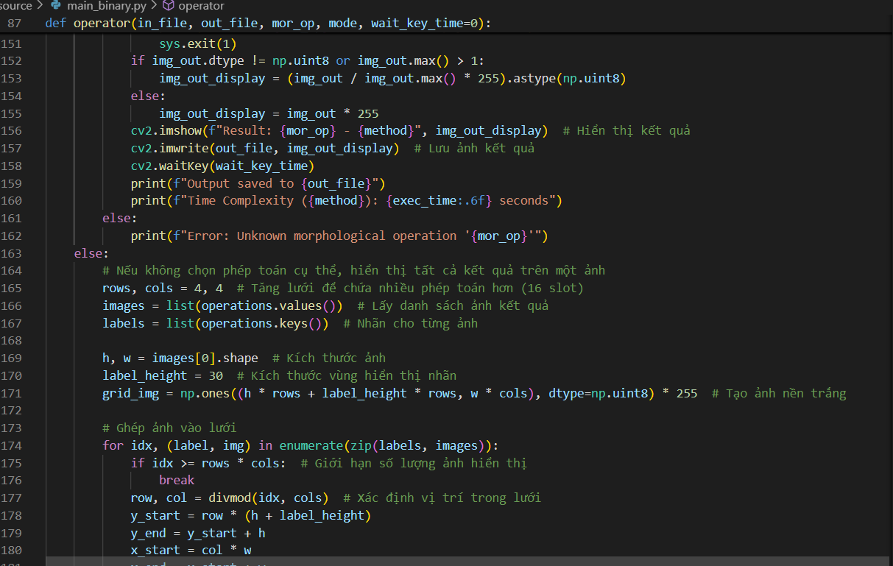

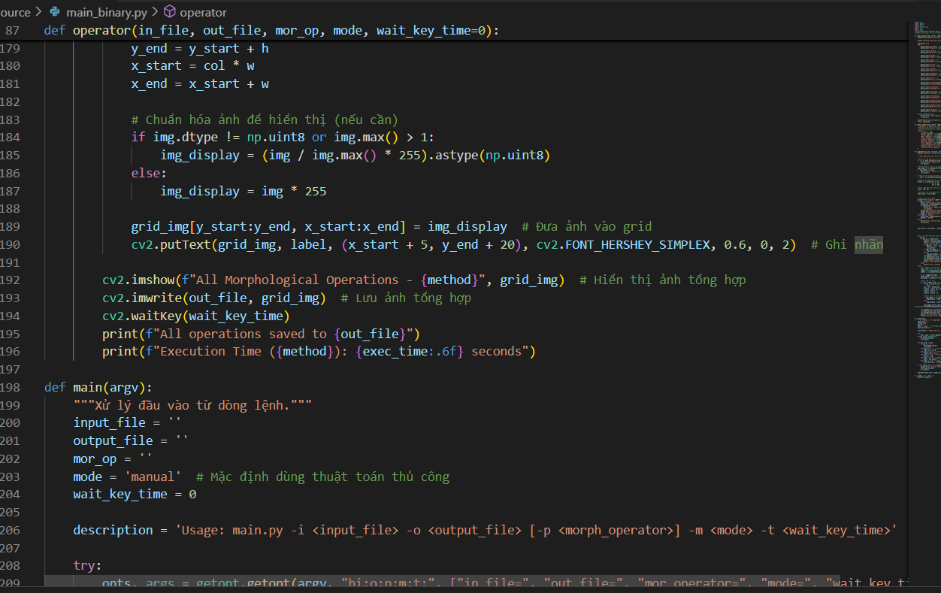

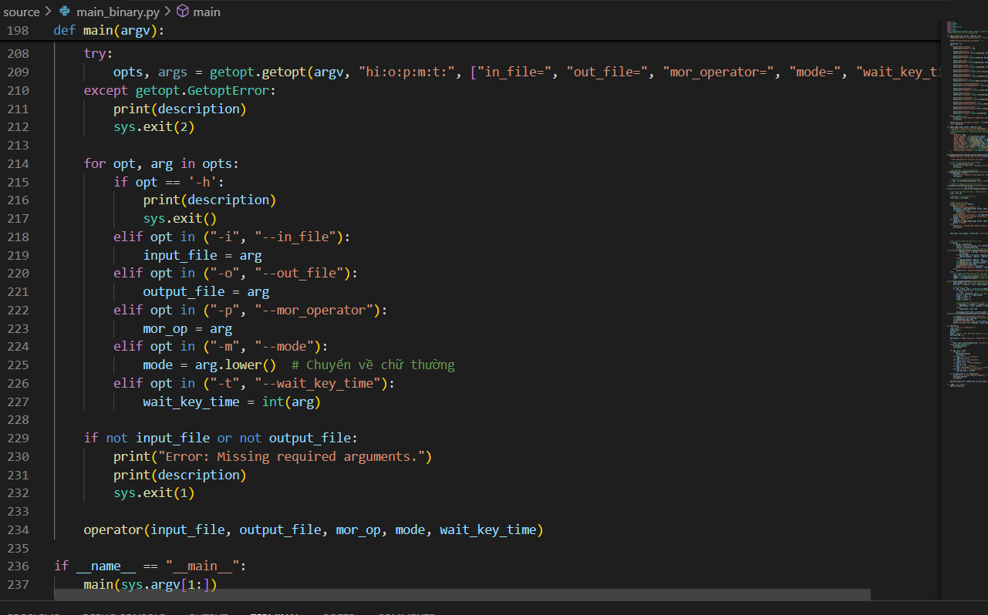

**main_grayscale.py**

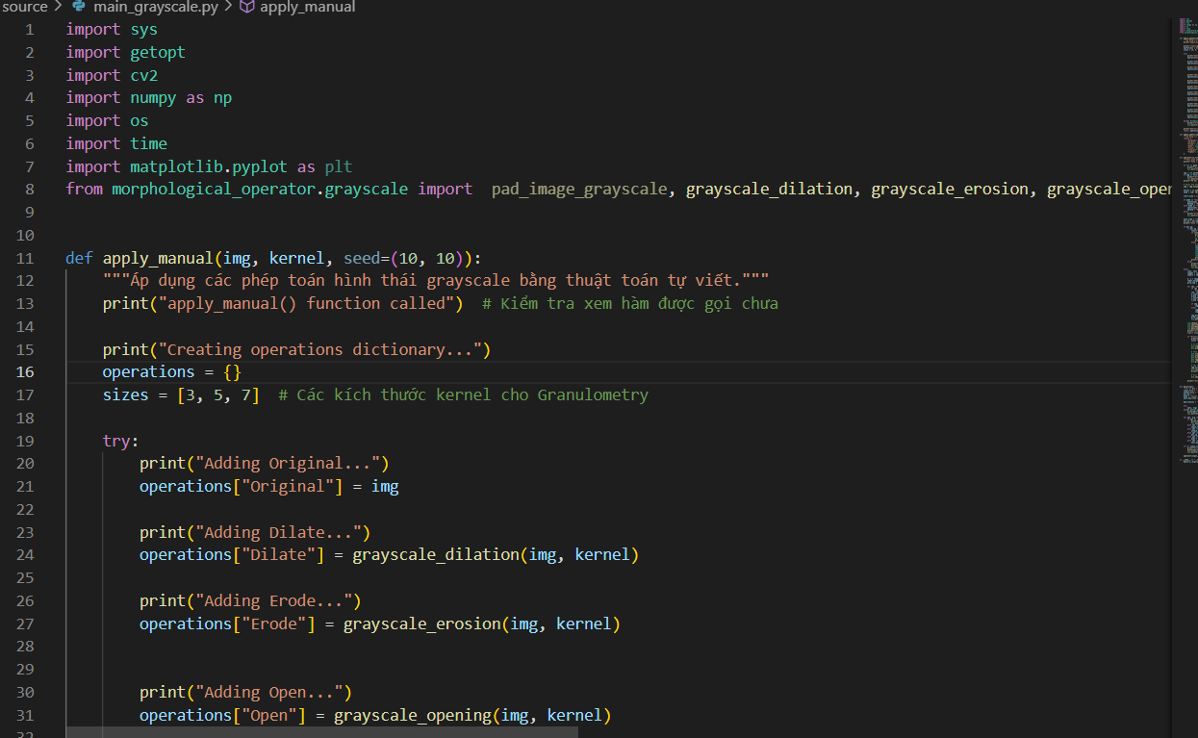

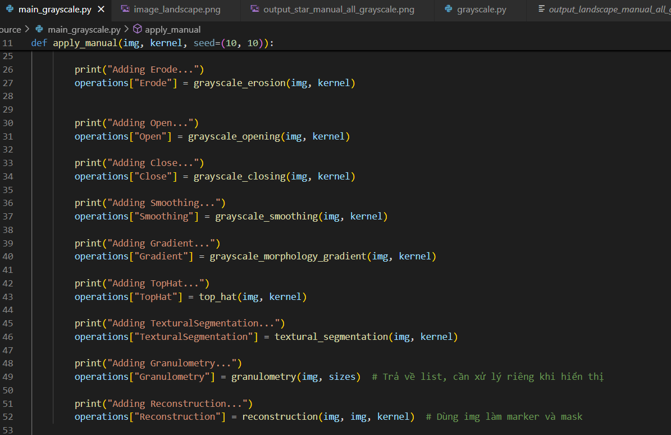

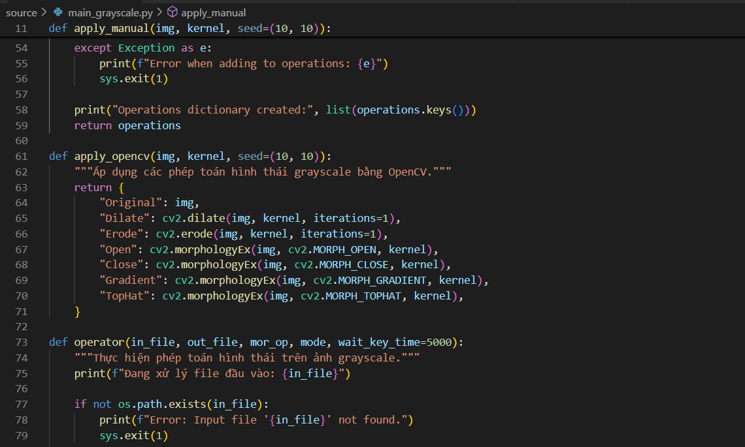

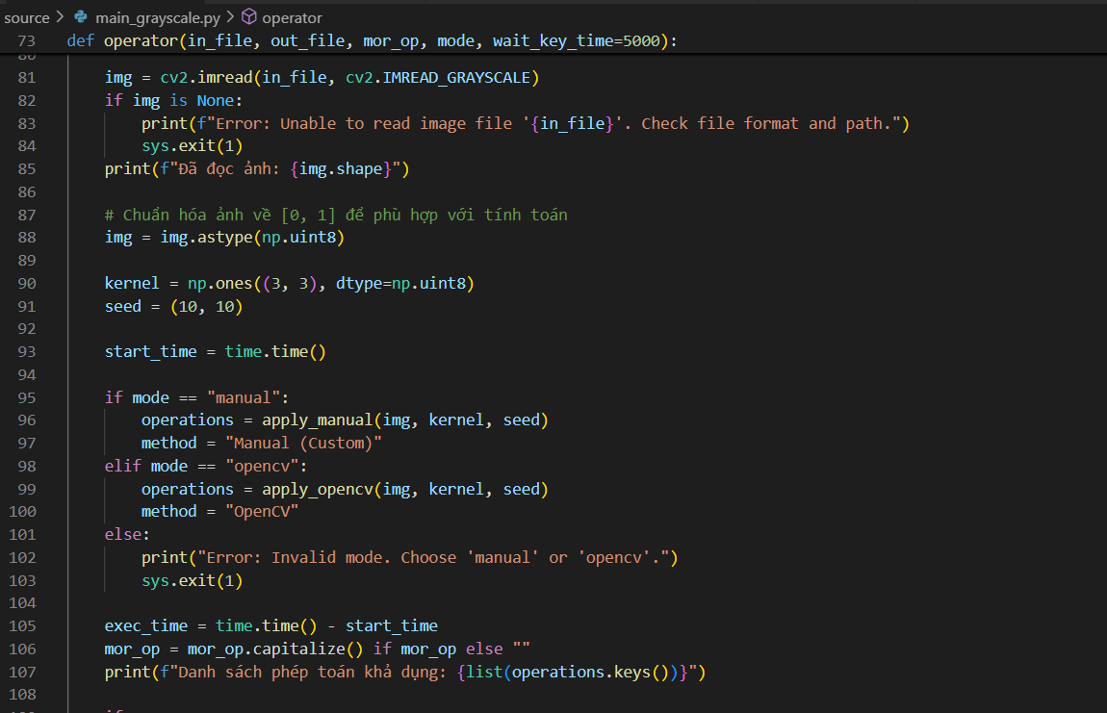

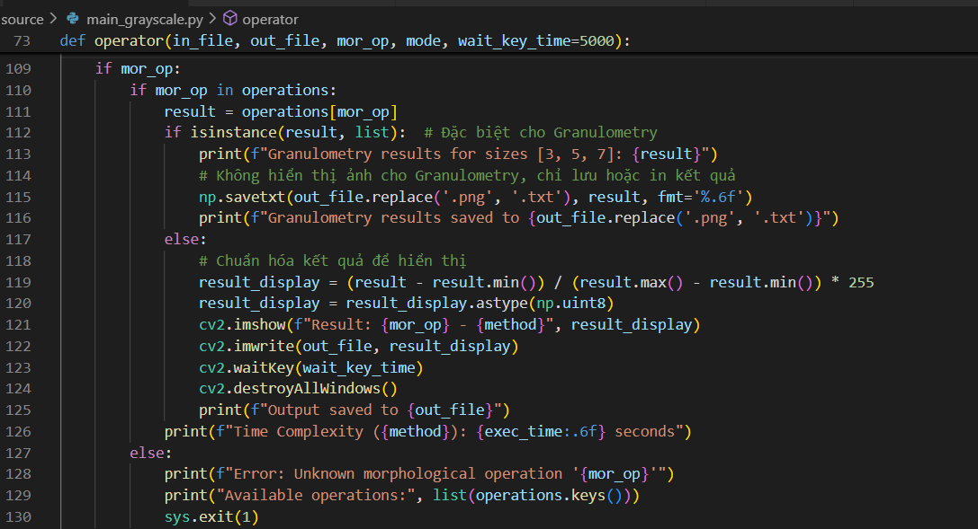

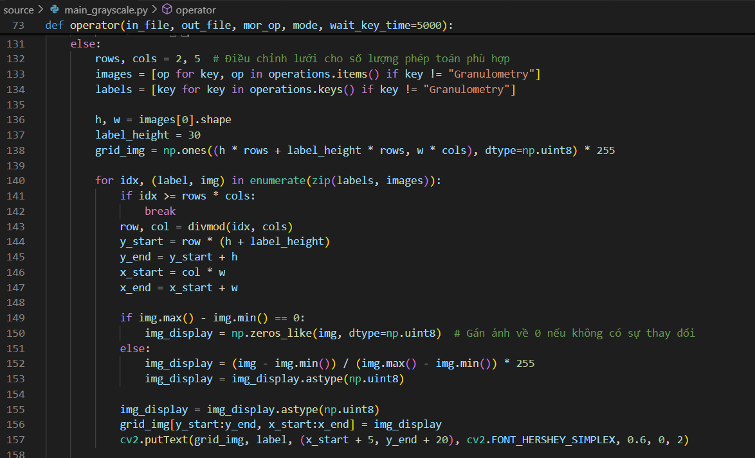

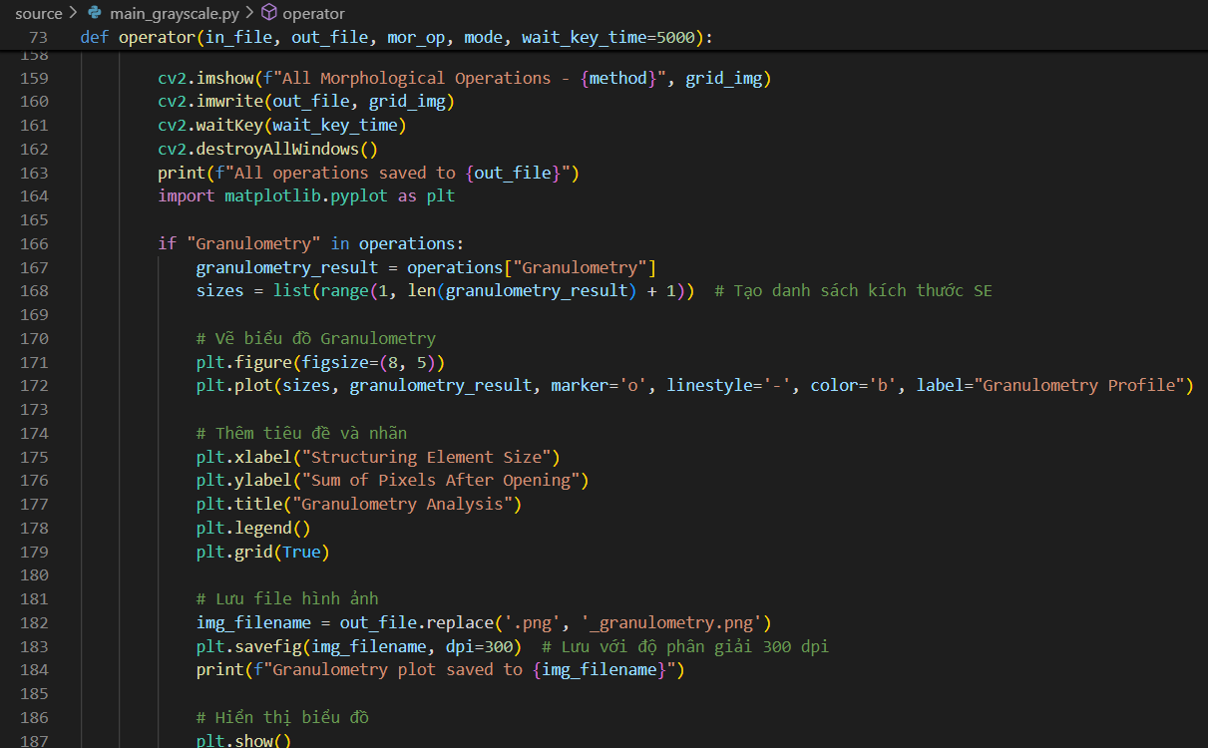

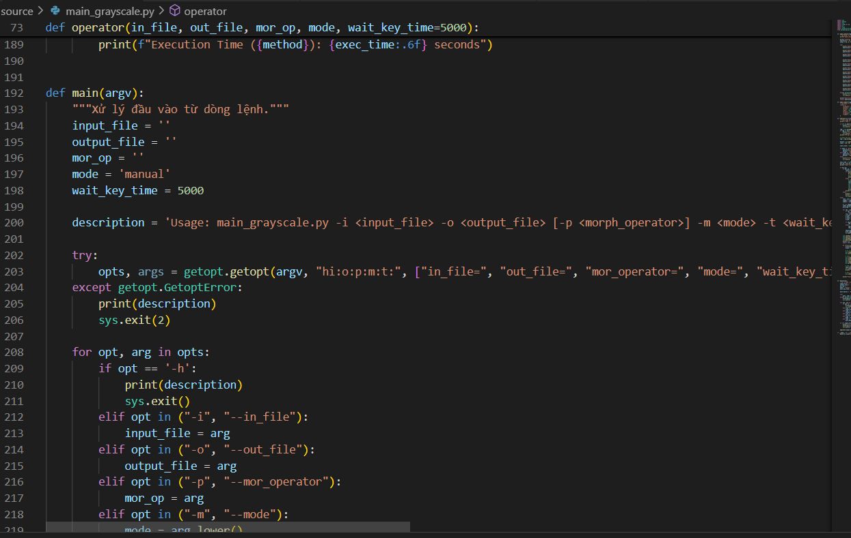

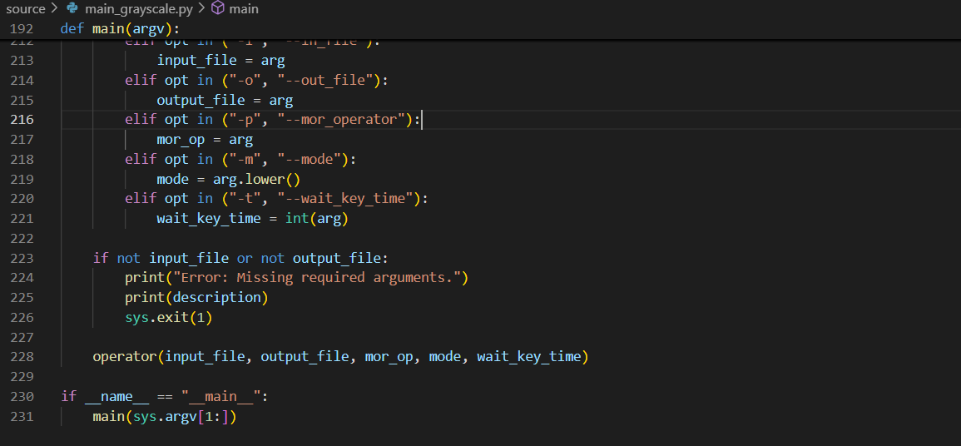

**III. Summarization of the usage**

**Detailed Usage and Algorithm Explanation:**

**Binary image.**

**1. pad_image(img, kernel)**

* **Usage:** Adds padding to the image to prevent overflow errors when applying morphological operations. The padding size is determined by the kernel's shape.
* **Algorithm Explanation:**
  + The function calculates the padding required for height (pad_h) and width (pad_w) based on the kernel size.
  + It then uses np.pad() to add zero-padding to the image around the borders.
  + This ensures that the kernel fits within the image boundaries during operations.

**2. erode(img, kernel)**

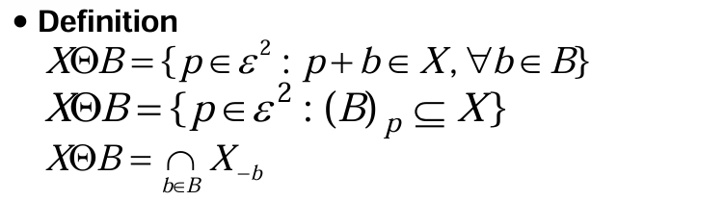

* **Usage:** Performs erosion on a binary image. Erosion shrinks bright regions by removing pixels at the borders of bright regions.
* **Algorithm Explanation:**
  + The function first pads the image to prevent boundary errors during erosion.
  + It then iterates over each pixel of the image.
  + For each pixel, it extracts a region equal to the kernel's size.
  + The region is compared with the kernel, and if it matches, the pixel is set to 1 in the result.
  + Otherwise, the pixel remains 0, thus shrinking bright areas.

**3. dilate(img, kernel)**

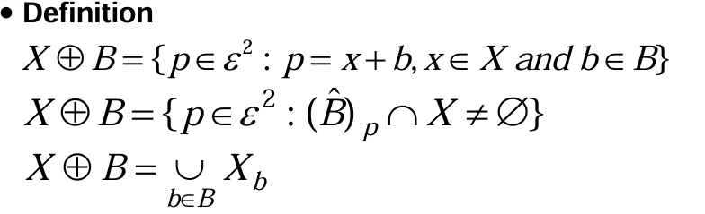

* **Usage:** Performs dilation on a binary image. Dilation expands bright regions by adding pixels to the borders of bright regions.
* **Algorithm Explanation:**
  + The image is padded to handle boundary issues.
  + The function iterates through each pixel, extracting a region the size of the kernel.
  + If any pixel in the region is 1 (according to the kernel), the center pixel in the result is set to 1, thereby expanding bright regions.

**4. opening(img, kernel)**

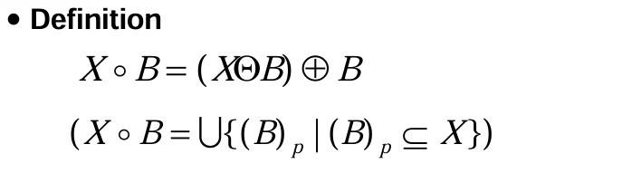

* **Usage:** Performs the opening operation, which is a sequence of erosion followed by dilation. It is used to remove small noise or isolate small bright regions.
* **Algorithm Explanation:**
  + First, erosion is applied to remove small bright regions.
  + Then, dilation is applied to restore the remaining regions while keeping small noise removed.
  + The result is smoother and cleaner, especially for small objects.

**5. closing(img, kernel)**

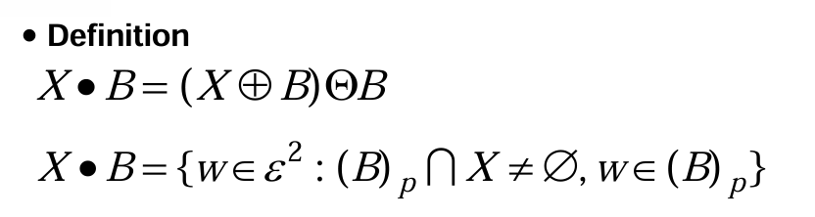

* **Usage:** Performs the closing operation, which is a sequence of dilation followed by erosion. It is used to close small holes or gaps in bright regions.
* **Algorithm Explanation:**
  + First, dilation is applied to expand bright regions and fill small holes.
  + Then, erosion is applied to restore the expanded regions, closing any gaps or small holes in the bright areas.

**6. hit_or_miss(img, kernel)**

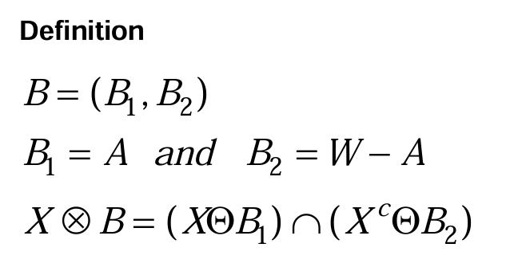

* **Usage:** Performs the Hit-or-Miss operation to detect specific shapes or patterns in the image.
* **Algorithm Explanation:**
  + The kernel is divided into two parts: the foreground (where the kernel has 1s) and the background (where the kernel has -1s).
  + The function erodes the original image with the foreground kernel and the complement of the image with the background kernel.
  + The result is a logical AND between the two eroded images, producing regions where both conditions are satisfied (i.e., the specific shape is found).

**7. boundary_extraction(img, kernel)**

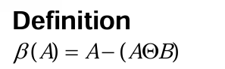

* **Usage:** Extracts the boundaries of bright regions in the image.
* **Algorithm Explanation:**
  + The function performs erosion on the image and subtracts the eroded image from the original image.
  + The result is the boundary, or the outer edges, of the bright regions in the image.

**8. region_filling(img, kernel, seed)**

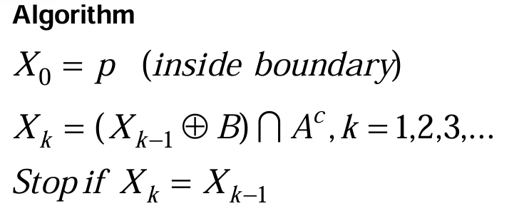

* **Usage:** Fills regions of bright areas starting from a seed pixel. This operation is useful for filling small holes or gaps within a bright region.
* **Algorithm Explanation:**
  + The function initializes a result image with all pixels set to 0 except for the seed pixel, which is set to 1.
  + It performs dilation iteratively on the result image, expanding the region starting from the seed, but only filling into areas that are part of the background.
  + The process continues until no changes occur between iterations, indicating that the entire region has been filled.

**9. connected_components(img)**

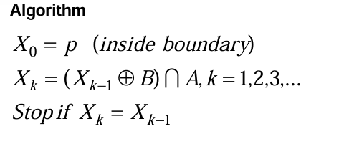

* **Usage**: Identifies and labels connected components in a binary image. Useful for separating distinct objects.
* **Algorithm Explanation**:
  + Initializes a label matrix with zeros and starts labeling from 1.
  + Iterates through the image, and when a foreground pixel (1) is found without a label, a flood-fill approach (using a queue) is used to assign the same label to all connected pixels.
  + Uses 8-connectivity (including diagonals) to ensure all connected pixels are grouped under the same label.
  + Returns an image where each connected component has a unique label.

**10. convex_hull(img)**

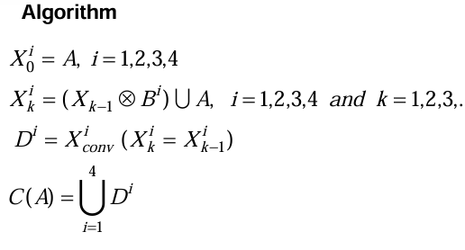

**Usage**: Computes the convex hull of bright regions using the Jarvis March (Gift Wrapping) algorithm. This is useful for shape analysis and object simplification.

**Algorithm Explanation**:

* Extracts all foreground pixel coordinates.
* Finds the leftmost point to start the hull.
* Iteratively selects the next point that forms the largest counter-clockwise angle with the current hull.
* Continues until the hull forms a closed shape.
* Returns a binary image where the convex hull is marked.

**11. thinning(img)**

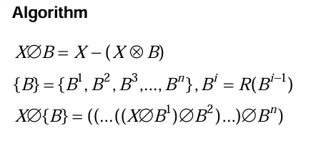

**Usage**: Reduces the thickness of objects to a single-pixel-wide skeleton using the Zhang-Suen algorithm. Useful for shape representation and handwriting recognition.

**Algorithm Explanation**:

* Iteratively removes border pixels while preserving connectivity.
* Uses two sub-iterations:
  + First pass removes pixels that satisfy specific neighborhood conditions.
  + Second pass removes a different set of pixels.
* Stops when no further changes occur.
* Returns a skeletonized version of the image.

**12. thickening(img, kernel)**

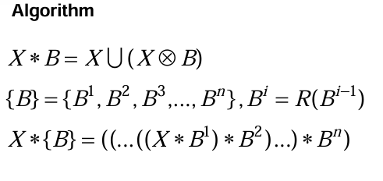

**Usage**: Expands objects in the binary image while preserving their general structure. Often used for strengthening weak edges.

**Algorithm Explanation**:

* Applies dilation to the image using the given structuring element.
* Combines the dilated image with the complement of the original image to selectively thicken object boundaries.
* Returns the thickened binary image.

**13. skeletonization(img)**

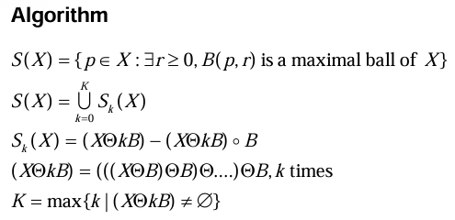

**Usage**: Extracts the medial axis (skeleton) of objects in a binary image while preserving topology. Useful for shape representation.

**Algorithm Explanation**:

* Iteratively applies erosion to the image.
* At each step, the difference between the eroded image and its opened version is stored as part of the skeleton.
* The process stops when the image is completely eroded.
* Returns the extracted skeleton.

**14. reconstruction(marker, mask, kernel)**

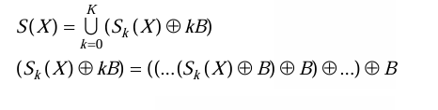

* **Usage**: Reconstructs an image by iteratively propagating bright pixels from a marker image while being constrained by a mask image. Useful for restoring objects after opening operations.
* **Algorithm Explanation**:
  + Initializes the marker image with a given seed region.
  + Iteratively applies dilation to expand the marker image while ensuring it does not exceed the mask image.
  + Stops when no further changes occur.
  + Returns the reconstructed image.

**15. pruning(skeleton, iterations)**

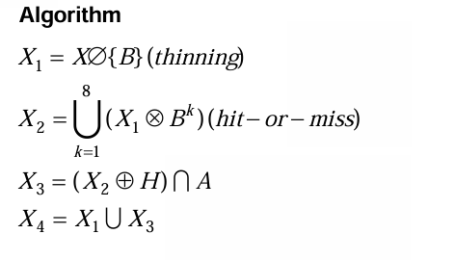

**Usage**: Removes extraneous endpoints from a skeletonized image to refine its structure. Often used to clean up noisy skeletons.

**Algorithm Explanation**:

* Identifies endpoints in the skeleton (pixels with only one neighbor).
* Iteratively removes these endpoints up to the specified number of iterations.
* Returns a pruned version of the skeleton.

**GRAYSCALE IMAGE**

**1. Grayscale Dilation**

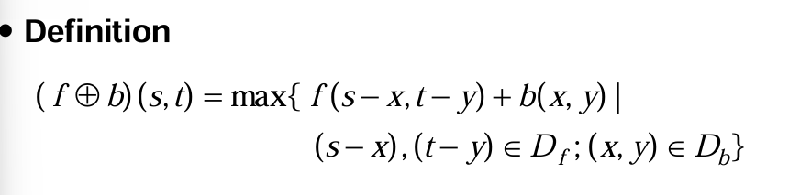

* **Usage**: Expands bright regions in a grayscale image by replacing each pixel with the maximum value in its neighborhood. Enhances bright structures.
* **Algorithm Explanation**:
  + Applies padding to the image to avoid boundary issues.
  + Iterates through the image, replacing each pixel with the maximum value within the structuring element.
  + Returns the dilated grayscale image.

**2. Grayscale Erosion**

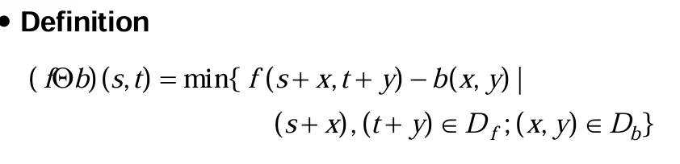

**Usage**: Shrinks bright regions by replacing each pixel with the minimum value in its neighborhood. Removes small bright details.

**Algorithm Explanation**:

* Applies padding to handle boundary effects.
* Iterates through the image, replacing each pixel with the minimum value within the structuring element.
* Returns the eroded grayscale image.

**3. Grayscale Opening**

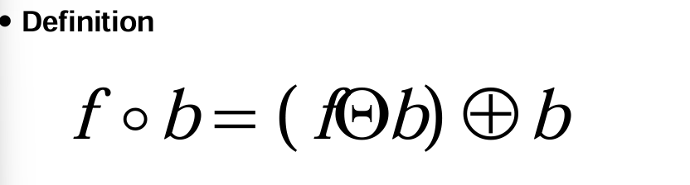

* **Usage**: Removes small bright spots by first performing erosion (shrinking objects) followed by dilation (restoring shape). Helps with noise reduction.
* **Algorithm Explanation**:
  + Applies grayscale erosion to shrink bright areas.
  + Applies grayscale dilation to restore larger structures.
  + Returns the processed grayscale image.

**4. Grayscale Closing**

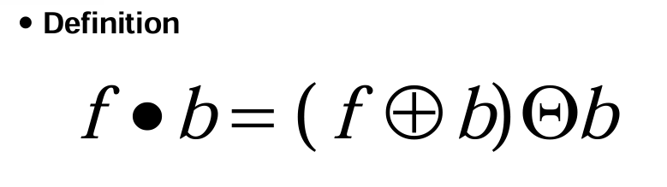

**Usage**: Fills small dark gaps by first performing dilation (expanding objects) followed by erosion (shrinking back). Helps close small holes in bright areas.

**Algorithm Explanation**:

* + Applies grayscale dilation to expand bright areas.
  + Applies grayscale erosion to restore original object shapes.
  + Returns the processed grayscale image.

**5. Grayscale Smoothing**

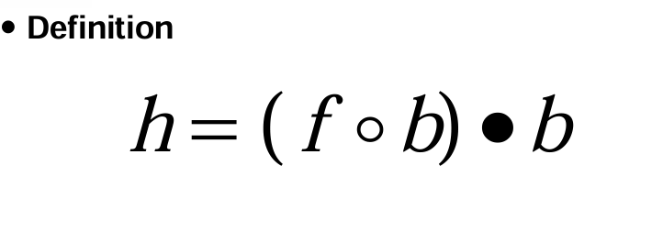

* **Usage**: Reduces noise and smooths object boundaries by applying both grayscale opening and closing sequentially.
* **Algorithm Explanation**:
  + First applies grayscale opening to remove small bright spots.
  + Then applies grayscale closing to fill small dark holes.
  + Returns the smoothed grayscale image.

**6. Morphology Gradient**

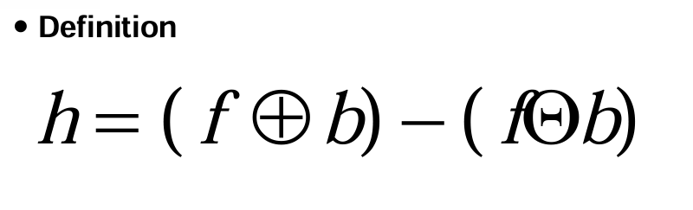

* **Usage**: Highlights object edges by computing the difference between dilated and eroded versions of the image. Enhances edge features.
* **Algorithm Explanation**:
  + Computes the difference: **(Dilation - Erosion)**.
  + Bright areas indicate regions with

**7. Top Hat**

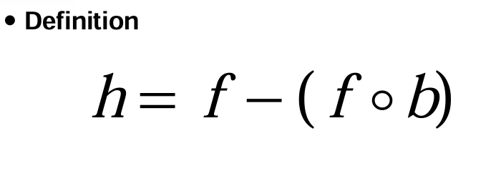

* **Usage**: Extracts small bright details by subtracting the opened image from the original. Useful for enhancing fine structures.
* **Algorithm Explanation**:
  + Applies **grayscale opening** to remove small bright regions.
  + Subtracts the opened image from the original image, preserving only small bright details.
  + Returns the top-hat transformed image.

**8. Textual segmentation**

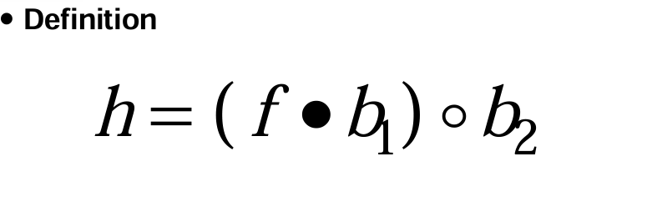

* **Usage**: Enhances texture features in an image by extracting fine structures using the top-hat transformation.
* **Algorithm Explanation**:
  + Uses **top-hat transformation** to highlight small bright details.
  + Enhances textural patterns by emphasizing variations in local brightness.
  + Returns the segmented image emphasizing textures.

**9. Granulometry**

* **Usage**: Analyzes the size distribution of bright structures by applying **grayscale opening** with different structuring element sizes.
* **Algorithm Explanation**:
  + Iterates through different kernel sizes.
  + Applies **grayscale opening** at each size to filter out smaller bright regions.
  + Computes the sum of pixels after each opening, indicating the presence of structures of different sizes.
  + Returns a list of summed pixel values for different kernel sizes, used to plot a granulometry curve.

**10. Reconstruction**

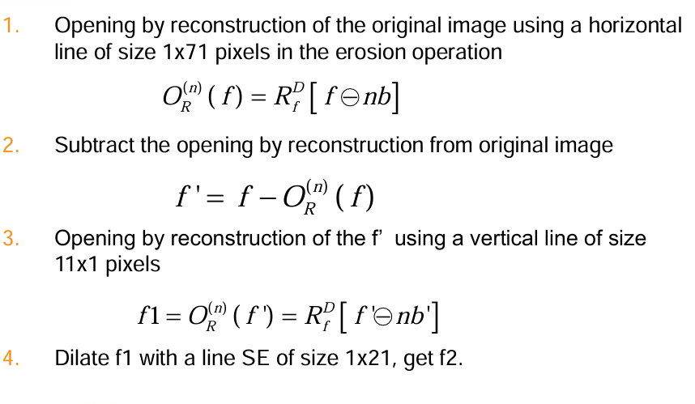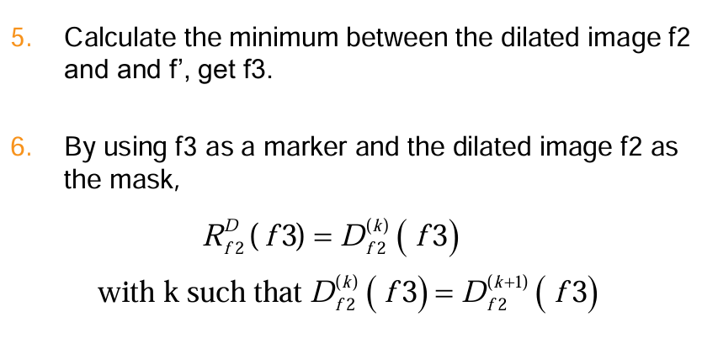

* **Usage**: Restores missing or occluded image regions by iteratively applying **dilation** constrained by a mask.
* **Algorithm Explanation**:
  + Initializes a **marker** image, typically a subset of the mask.
  + Iteratively dilates the marker while ensuring it does not exceed the mask.
  + Stops when the marker no longer changes between iterations or reaches **max_iter**.
  + Returns the reconstructed grayscale image.

**IV. EXPERIMENTS AND EVALUATION:**

**1st to 7th function in binary.py**

**Test images:** The algorithm on a test set consisting of images with different sizes, brightness levels, colors, structure and complexities as below:



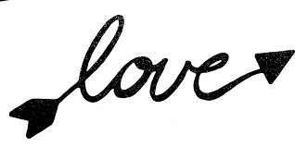



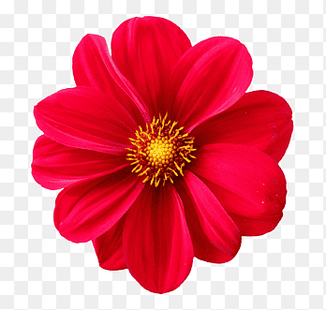

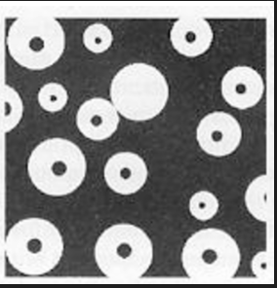

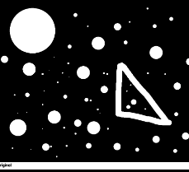

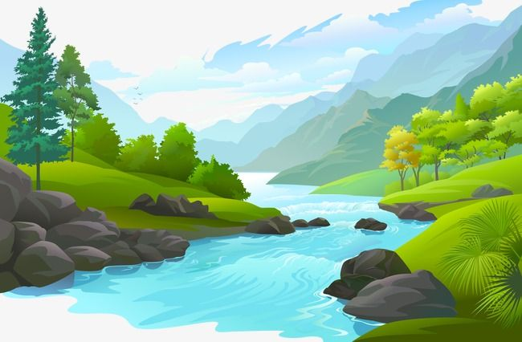

***Results with opencv mode vs manual mode:***

**Text_tnr.png**

Execution Time (Manual (Custom)): 15.685021 seconds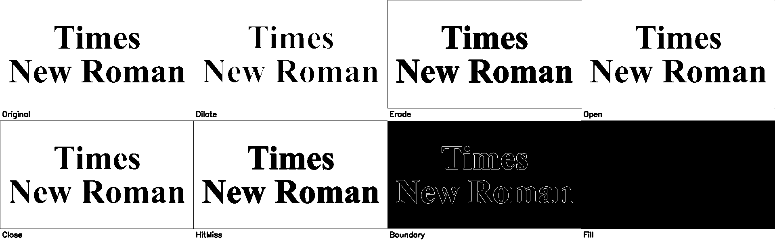

Execution Time (OpenCV): 0.002056 seconds

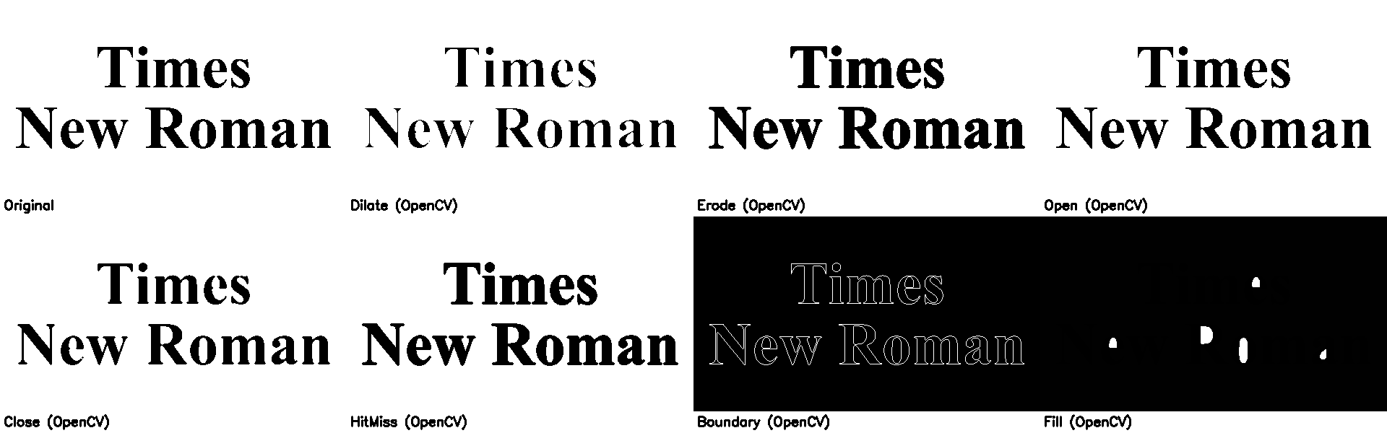

**Comments:**

Similar results in morphological operations, but the OpenCV built-in method using flood filling missed some regions. OpenCV is significantly faster than the custom implementation.

**Lover.png**

Execution Time (Manual (Custom)): 6.485807 seconds

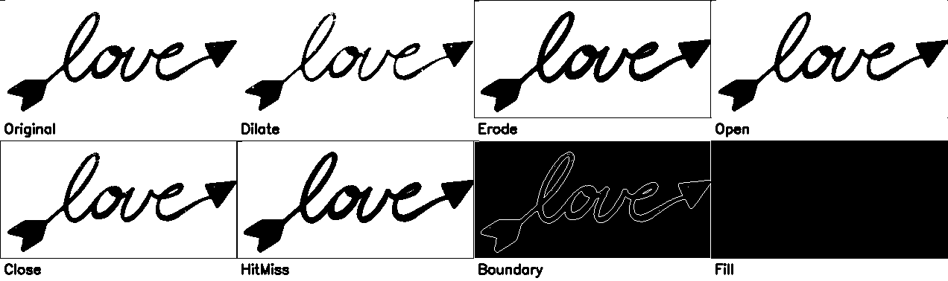

Execution Time (OpenCV): 0.000000 seconds

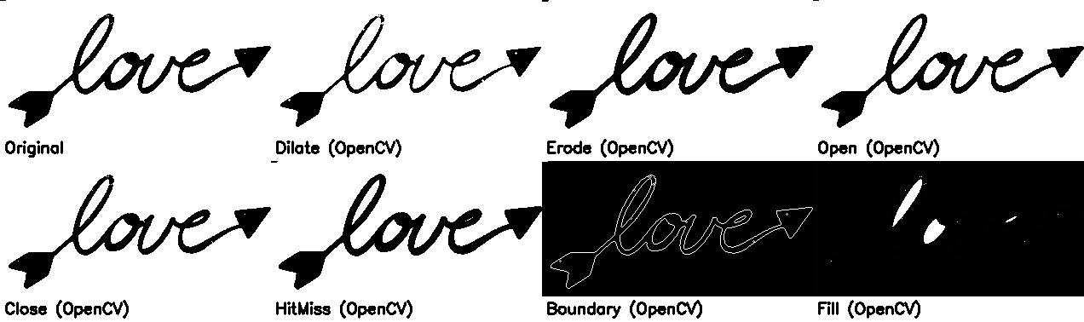

**Comments:**

Similar results in morphological operations, but the OpenCV built-in method using flood filling missed some regions. OpenCV is significantly faster than the custom implementation.

**Discover.jpg**

Execution Time (Manual (Custom)): 30.812511 seconds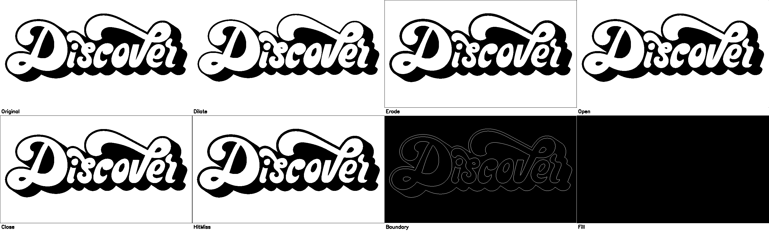

Execution Time (OpenCV): 0.004053 seconds

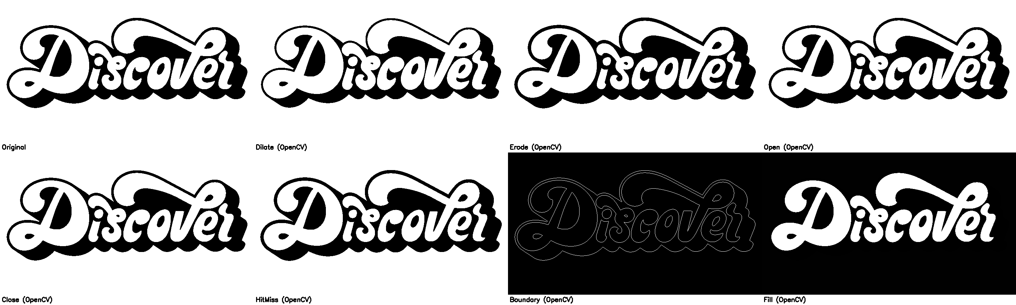

**Comments:**

Similar results in morphological operations, but the OpenCV built-in method using flood filling missed some regions. OpenCV is significantly faster than the custom implementation.

**Flower.png**

Execution Time (Manual (Custom)): 9.767103 seconds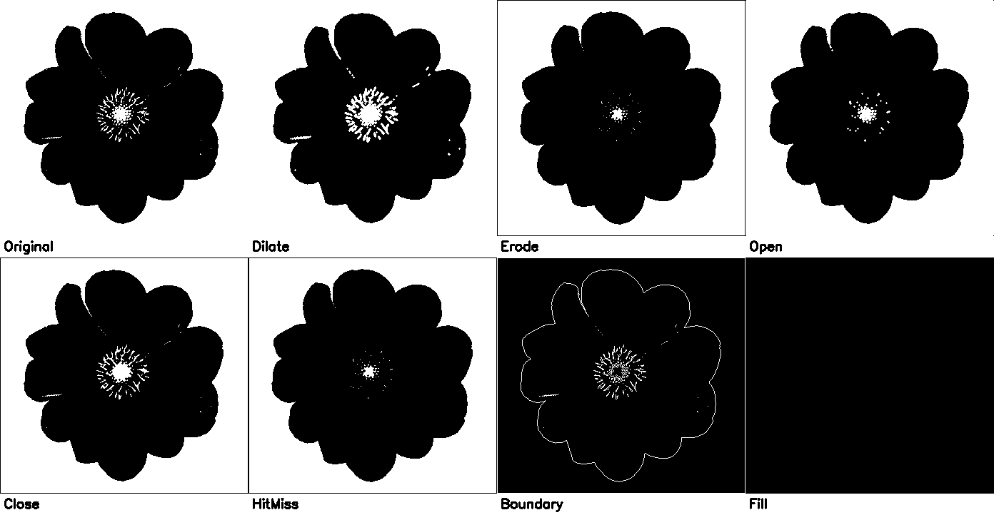

Execution Time (opencv): 0.016066 seconds

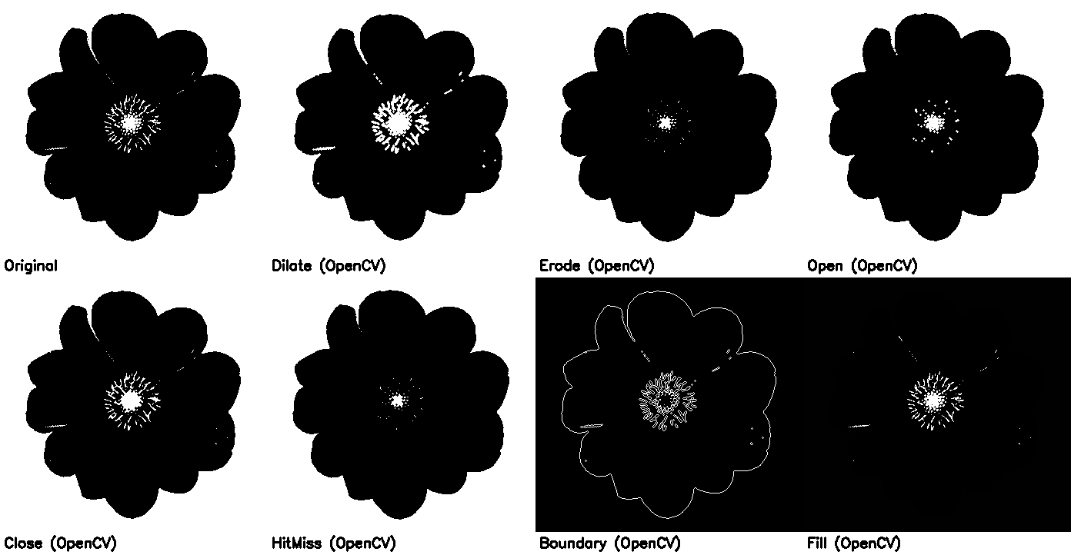

**Comments:**

Similar results in morphological operations, but the OpenCV built-in method using flood filling missed some regions. OpenCV is significantly faster than the custom implementation.   
Boundary operator (openCV) mode is more detailed than the custom version

**Circle.png**

Execution Time (manual): 7.076829 seconds

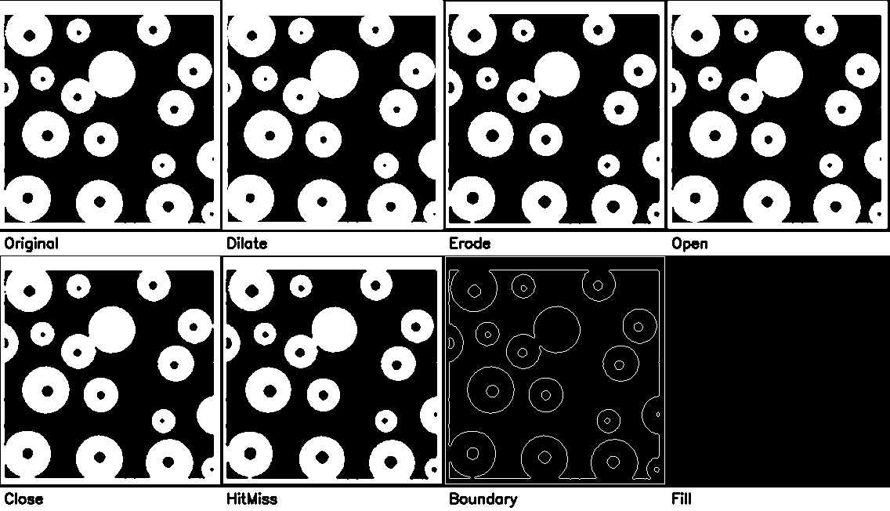

Execution Time (opencv): 0.016066 seconds

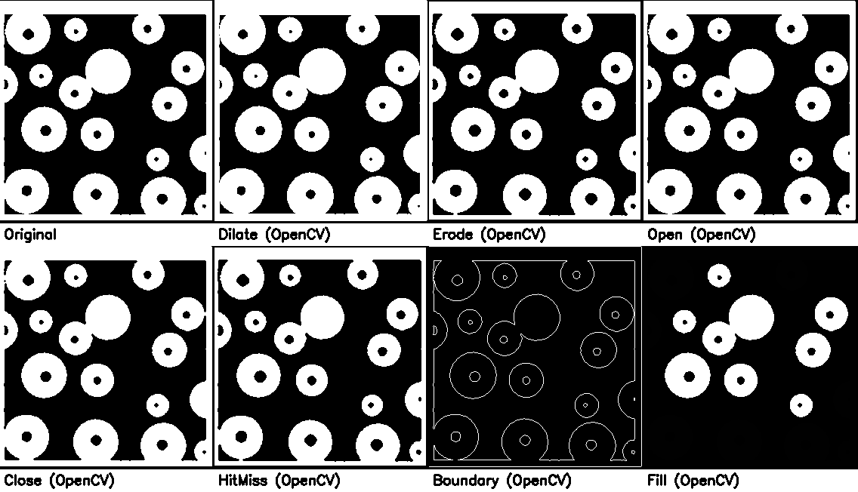

**Comments:**

Similar results in morphological operations, but the OpenCV built-in method using flood filling missed some regions. OpenCV is significantly faster than the custom implementation.

**Star.png**

Execution Time (manual): 299.239042 seconds

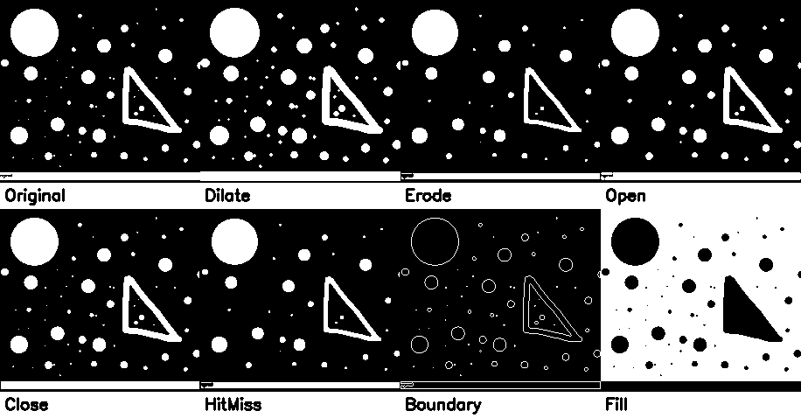

Execution Time (opencv): 0.000000 seconds

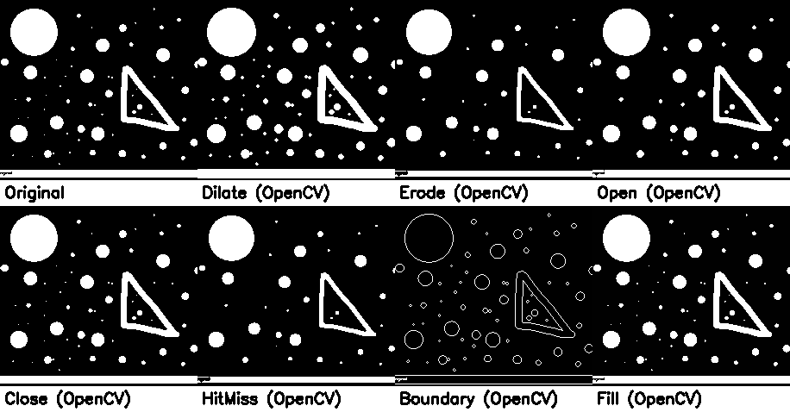

**Comments:**

Similar results in morphological operations, but the OpenCV built-in method using flood filling missed some regions. OpenCV is significantly faster than the custom implementation.   
Boundary operator (openCV) mode is more detailed than the custom version.

Region filling (manual) is not as expected, wrong region.

**Landscape.png**

Execution Time (manual): 24.075548 seconds 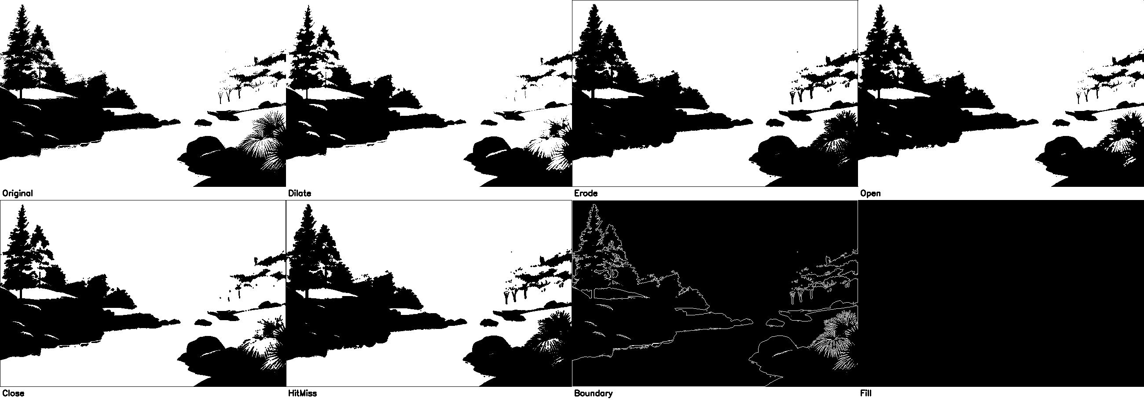

Execution Time (opencv): 0.005046 seconds

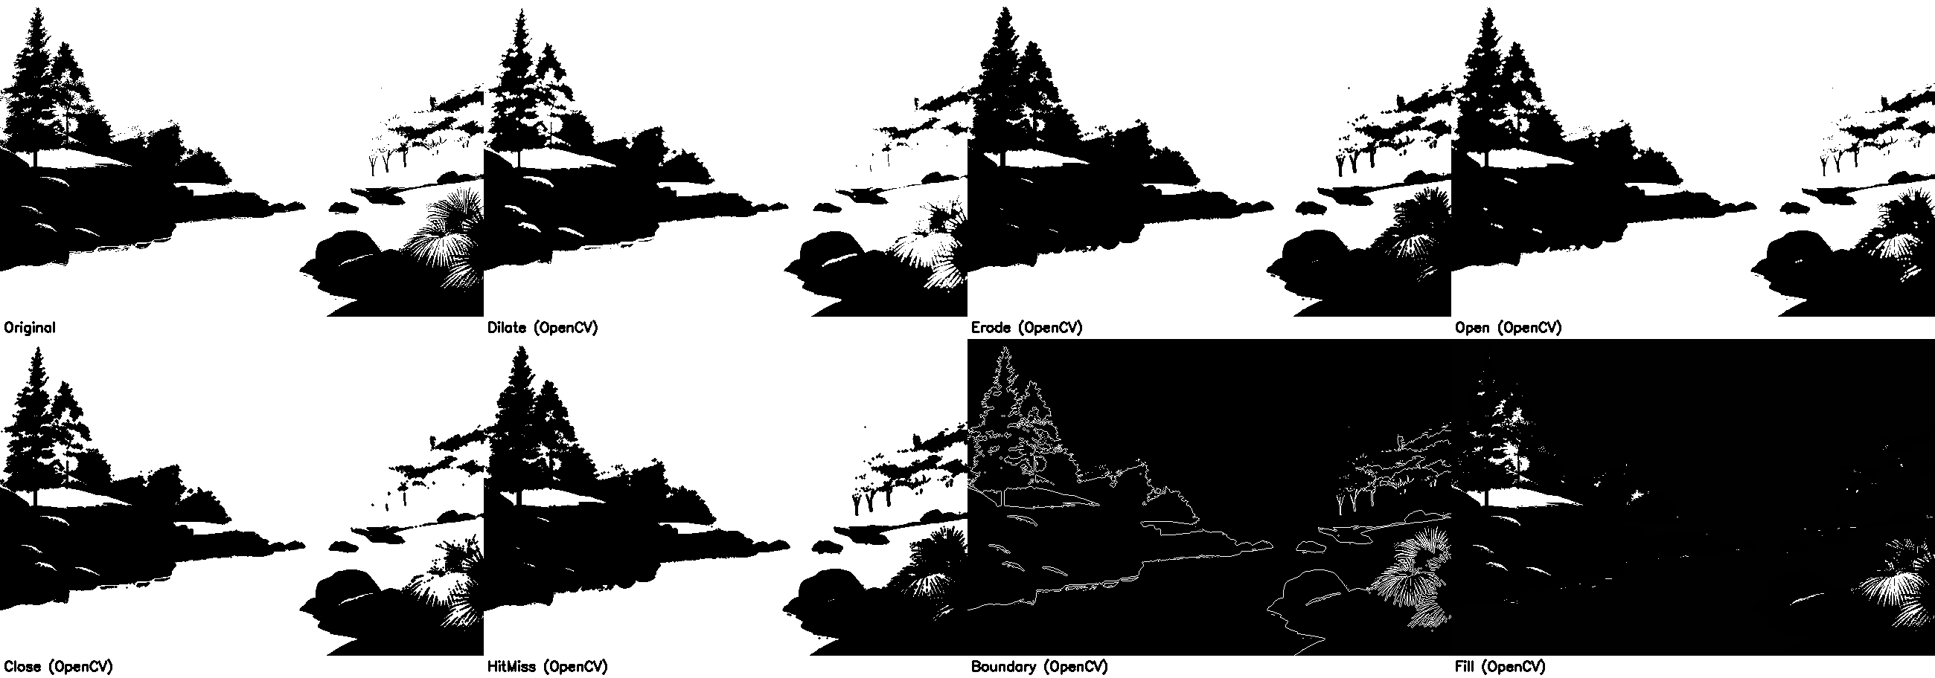 **Comments:**

Similar results in morphological operations, but the OpenCV built-in method using flood filling missed some regions. OpenCV is significantly faster than the custom implementation.   
Boundary operator (openCV) mode is more detailed than the custom version

**7st to 14th function in binary.py and 10 operators in grayscale image**

I only test with star.png (the left function) và landscape.png (grayscale image)

Manual results:

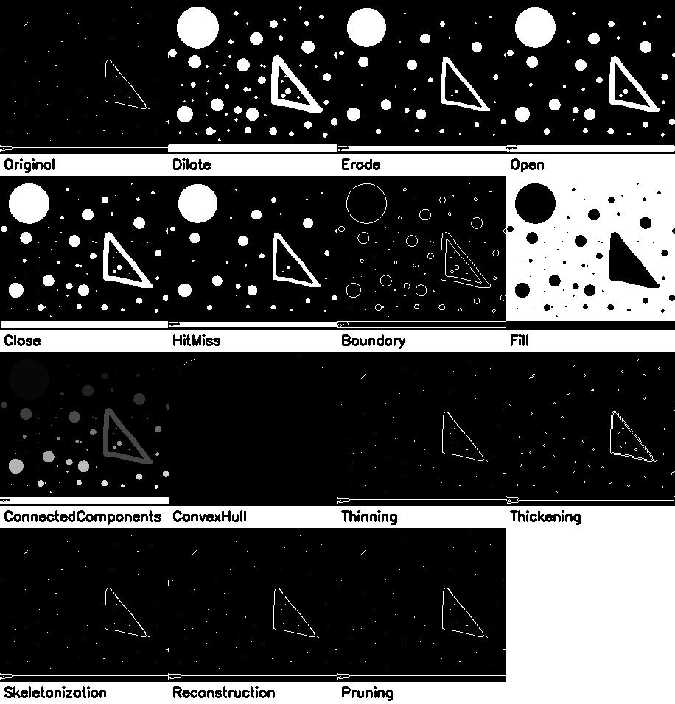

Opencv results:



**Comments:**

Similar results in morphological operations, but the OpenCV built-in method using flood filling missed some regions. OpenCV is significantly faster than the custom implementation.   
Boundary operator (openCV) mode is more detailed than the custom version.

Region filling (manual) is not as expected, wrong region.

**Grayscale image.**

**The results of granulometry function on landscape grayscale image**

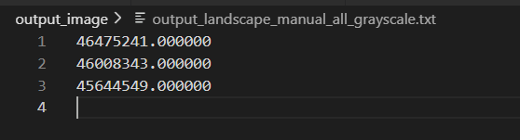

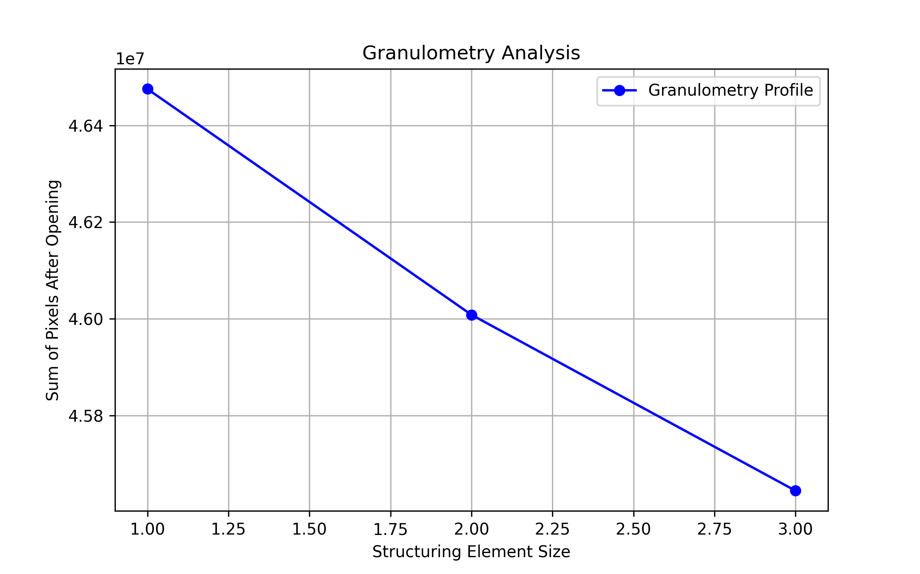

**The Granulometry output file now contain different values**

granulometry function is now producing **three distinct values:**

* **46475241.000000**
* **46008343.000000**
* **45644549.000000**

**What do these values represent?**

Each value corresponds to the **sum of pixel intensities** after applying **Grayscale Opening** with different structuring element (SE) sizes.

* The first value (**46475241.000000**) corresponds to **SE size 3x3**.
* The second value (**46008343.000000**) corresponds to **SE size 5x5**.
* The third value (**45644549.000000**) corresponds to **SE size 7x7**.

**Why do the values decrease?**

As the structuring element **size increases**, **more small bright regions are removed**, leading to a **reduction in total pixel intensity**.

* **Smaller SEs (3x3)** only remove very small noise.
* **Larger SEs (7x7)** remove larger details and thin structures, reducing the total pixel sum.

**What does this tell us about the image?**

* The image **contains small bright structures** that are gradually removed as SE size increases.
* The decrease in values suggests **progressive removal of finer details**, which aligns with granulometry analysis.
* If values stayed **constant**, it would mean **no small structures were removed**, or SE sizes were **too small** to affect the image.

Opencv results

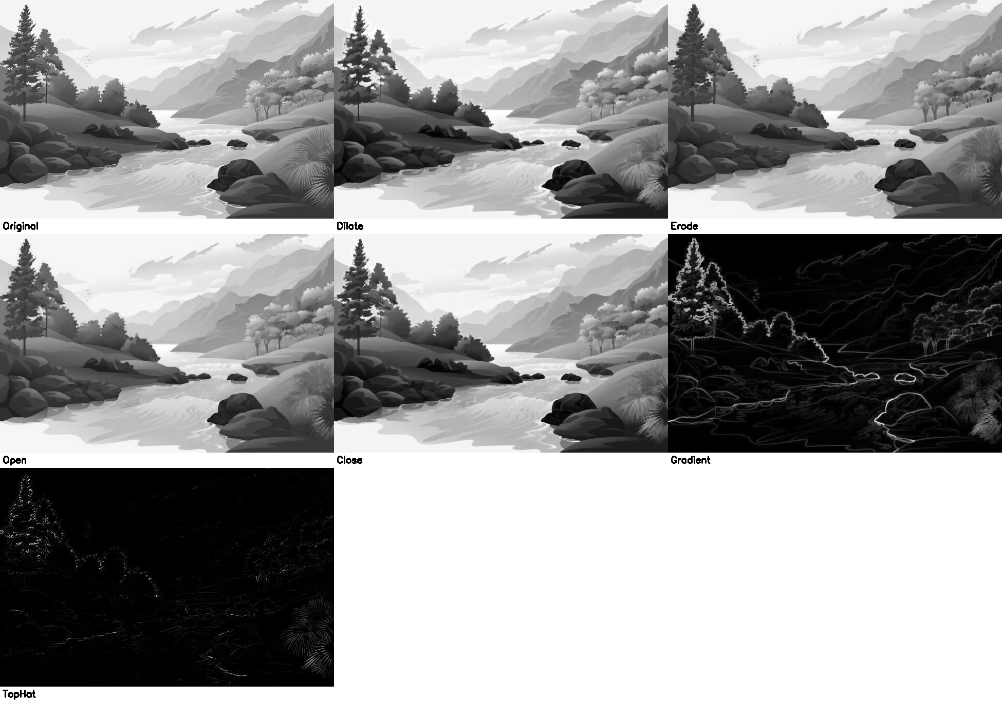

Manual results:

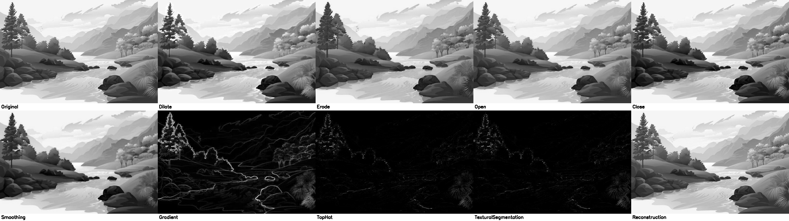

**Comments:**

The custom grayscale morphological operations produce results that often differ from OpenCV's built-in functions, with some outputs appearing darker or less refined. OpenCV generally provides smoother and more accurate transformations due to optimized padding, normalization, and efficient kernel application. The main issues in the custom implementation likely stem from **inefficient pixel scaling, boundary handling, and loop-based computations**. Refining these aspects could improve accuracy and bring results closer to OpenCV’s optimized output.

**Comparison in general**

**Binary image and grayscale image operator custom vs opencv built in**

|  |  |  |
| --- | --- | --- |
| **Aspect** | **Custom Implementation** | **OpenCV Implementation** |
| **Performance (Speed)** | Slow (nested loops, sequential processing) | Fast (optimized C++ backend, SIMD, parallel processing) |
| **Accuracy** | Can be prone to errors (padding issues, structuring element misalignment) | Highly reliable and precise |
| **Dilation & Erosion** | Works if implemented correctly but slower | Optimized and fast |
| **Opening & Closing** | Affected by dilation/erosion accuracy | Standardized and efficient |
| **Hit-or-Miss** | May introduce errors if background processing is incorrect | Handles structuring elements correctly |
| **Boundary Extraction/ Gradient** | Accurate if erosion is properly done | Faster with correct results |
| **Region Filling** | Uses iterative dilation, slow for complex shapes | Uses flood fill, faster and more memory-efficient |
| **Thinning** | Works but may leave artifacts if conditions aren't checked properly | Optimized and standardizes Zhang-Suen or Guo-Hall algorithms |